

PROJECT REPORT

Provision of Continuing Professional Development for
Non-Medical Prescribing within the
Surrey and Sussex Region of
NHS South East Coast

A Training Needs Analysis

Dr Anita J. Green* Lecturer (Clinical)
Dr Olwyn M. R. Westwood Reader in Medical Education
Professor Pam Smith Director of the Centre for Research in
Nursing & Midwifery Education
* Principal Investigator for the project

Project proposed and co-ordinated for NHS South East Coast by
Fiona Peniston-Bird, Non-Medical Prescribing Facilitator



Acknowledgements

The project team would like to thank the following people for their help with this project:

- Fiona Peniston-Bird for her support, advice and guidance.
- Penny Robinson, Claire White and Christalla Mouzoures from the Centre for Research in Nursing and Midwifery Education for their administrative support.
- The NHS South East Coast NMP steering group: Fiona Peniston-Bird, Robert Lea, Gail Fleming, Rachel Gosling, Richard Bell, Carroll Siu, Sue McKnight, Dr Kevin Pankhurst, Liz Clay & Mike Salter.

In particular the project team would like to thank all the participants who contributed to the project through completing questionnaires and being interviewed.

CONTENTS
1. OVERVIEW AND RECOMMENDATIONS 6
1. 1. OVERVIEW 6
1.2. RECOMMENDATIONS 6
1.2.1. Core Modules for Non-Medical Prescribers 6
1.2.2. Continuing Professional Development (CPD) 6
1.2.3. General Recommendations for Education Courses (Modules and CPD) 7
2. BACKGROUND TO THE INTRODUCTION OF NON-MEDICAL PRESCRIBING IN THE UK 9
2.1. INTRODUCTION 9
Table 1. Timetable of Change: Introduction of Non-Medical Prescribers in the UK 9
2.2. PHARMACISTS AND PRESCRIBING 10
2.3. RECENT CHANGES IN NON-MEDICAL PRESCRIBING 10
3. THE PROJECT 11
3.1. AIM and OBJECTIVES 11
3.1.1. The aim was to: 11
3.1.2. The objectives were to: 11
3.2. RESEARCH DESIGN AND METHODS 11
3.3. QUESTIONNAIRES 11
3.4. TELEPHONE INTERVIEWS 12
4. RESULTS 13
4.1. RESULTS FROM THE QUESTIONNAIRES 13
4.1.1. Surrey and Sussex SHA Database of non-medical prescribers. 13
Table 2. Replies to the Questionnaire 13
4.2. INFORMATION RETRIEVED FROM COMPLETED QUESTIONNAIRES 13
4.3. PROFESSIONAL AND PRACTICE EXPERIENCE DETAILS 13
Figure 1. Professional details of those who responded to the questionnaire 14
Table 3. Specialist areas within Surrey and Sussex SHA that employ non-medical prescribers (n=1 unless otherwise stated) 14
4.3.1. Experience in professional role: 15
Figure 2. The length of service in present professional role. 15
4.3.2. How respondents are employed and pay scale on the Agenda for Change: 15
4.3.3. Qualifications of the non-medical prescribers: 16
Table 4. General Qualifications of Respondents to the Questionnaire 16
4.3.4. Nature of the qualifications awarded in order to be eligible to prescribe 16
Table 5: Prescribing qualifications of respondents to the questionnaire 17
4.3.5. Time taken to qualify 17
Figure 3. Summary of the time taken to qualify by individual qualification 18
4.3.6. Where the non-medical prescribers studied 18
Figure 4. Summary of the location of HEI where qualifications were awarded 19
4.3.7. Appropriateness of the programmes of study 19
Figure 5. Appropriate knowledge base in the course studied to fulfill the role in non- medical prescribing (n = 261] 19
4.3.8. Confidence in prescribing 20
Table 6. Replies to the statement on respondents’ confidence in non-medical prescribing 21
4.3.9. Non-medical prescribing enhances the professional role 21
Table 7. Replies to the statement: 22
‘Non-medical prescribing enhances my professional role’ 22
Figure 6. Confidence as a non-medical prescriber: 23
4.3.10. Length of service in practice area 23
Table 8. Length of service in practice area 24
Table 9. How often respondents prescribe in their practice area 24
Table 10. Frequency with which respondents implemented a Clinical Management Plan with an Independent Medical Prescriber. 24
4.4. CONTINUING PROFESSIONAL DEVELOPMENT (CPD) 25
4.4.1. Course or programmes specific to clinical specialty 25
Figure 7. Completion of courses or programmes of study (specific to your clinical specialty) within the last 12 months provided by employer and other organisations 26
4.4.2. Mandatory study days provided by their employer 26
Figure 8. Completion of courses or programmes of mandatory study within the last 12 months provided by employer and other organisations 27
4.4.3. Specific to your role as a non-medical prescriber provided by the employer 28
4.4.4. Specific to your role as a non-medical prescriber provided by an organisation other than the employer 28
Figure 9. Completion of courses or programmes specific to non-medical prescriber role within the last 12 months provided by employer and other organisations 29
4.4.5. Attendance at conferences on non-medical prescribing within the last 12 months 29
Figure 10. Conferences attended on non-medical prescribing within the last 12 months provided by employer and other organisations (N = 270) and duration of course or programme provided by employer (N = 36) and other organisations (N = 26) 30
4.4.6. National Conferences 30
Table 11. Attendance at Conferences 31
4.4.7. Attendance at a Surrey and Sussex SHA conference within the last 12 months 31
Table 12. Replies to the statement: 32
Conferences where topics were applicable to the non-medical prescribers’ Practice 32
Figure 11. Surrey and Sussex SHA course or programme of study attended during the last 12 months 33
4.4.8. ‘Please rank your prescribing continuing professional development needs in order of importance.’ 33
Table 13. Principles of pharmacology 35
Table 14. Drug administration 35
Table 15. Patient/client assessment 36
Table 16. Non-medical prescribing information 36
Table 17. Physiology 36
Table 18. Psychopharmacology 37
Table 19. Biological sciences 37
Table 20. Decision-making skills 37
Table 21. Drug/pharmacology law 38
Table 22. Support for experienced prescribers 38
Table 23. Distance learning 39
Table 24. E-Learning 39
Table 25. Lectures 39
Table 26. Conferences 40
Table 27. In the practice setting with colleagues 40
Table 28. Short courses 40
Table 29. Training days 41
Table 30. Self-directed learning 41
4.5. OPEN ENDED QUESTIONS 41
4.5.1. Demands for CPD 41
Table 31. Comments on demands for continuing professional development (CPD) 42
4.5.2. Support for CPD in practice 42
Table 32. Comments on support for CPD in practice 43
4.5.3. Barriers to CPD 43
Table 33. Comments on barriers to CPD 43
4.5.4. Barriers to learning in practice 43
Table 34. Comments on barriers to learning in practice 44
4.6. DEMOGRAPHIC DATA OF THE RESPONDENTS 44
4.6.1 Gender 44
4.6.2. Age 44
Figure 12. Age group of respondents (n = 270) 44
Table 35. Ethnicity data of respondents (n = 270) 45
4.7. INFORMATION RETRIEVED FROM TELEPHONE INTERVIEWS 45
Table 36. Key stakeholders interviewed 45
4.8. FINDINGS 46
4.8.1. Medical assessors 46
4.8.2. Programme leaders 46
4.8.3. Clinical Managers 47
4.8.4. Prescribing Leads 48
4.8.5. Pharmacist 49
5. SUMMARY 50
5.1. What are the education and training gaps, deficits and limitations? 50
5.2. What CPD has been of use and for whom? 50
REFERENCES 52
APPENDIX 1: ADDITIONAL DATA 53
APPENDIX 2: QUESTIONNAIRE 57

OVERVIEW AND RECOMMENDATIONS

1. 1. OVERVIEW
The project to undertake a Training Needs Analysis for Non-Medical Prescribers was commissioned by the Surrey and Sussex Strategic Health Authority (Surrey and Sussex SHA). The aim of the analysis was to inform future policy, educational provision and practice development.

A sample of non-medical prescribers (n = 270) from a total population of 1249 was surveyed via an in-depth questionnaire, and 11 telephone interviews were conducted with a purposive sample of key stakeholders. We enquired about their perceived continuing education and training needs, in order to inform future provision for those practising in the Primary Care Trusts, Acute Hospital Trusts and Mental and Specialists Care Trusts of the Surrey and Sussex SHA. The report contains data collected to supply the following details about the respondents:

- Professional Qualifications;
- Practice Experience;
- Continuing Professional Development (CPD) Experiences Needs;
- Demographic Information.

In addition the respondents’ comments on their experiences and educational needs are also presented.

1.2. RECOMMENDATIONS
Surrey and Sussex SHA is in an excellent position to continue to develop its continuing professional development strategies guided by government directives on non-medical prescribing. Furthermore, the higher education institutions within the Surrey and Sussex SHA catchment area provide quality, up-to-date and appropriate education and training. Moreover, the non-medical prescribers questioned appear to be highly motivated and they provided supportive and constructive comments and feedback. Based on the findings, the recommendations arising from this training needs analysis are:

1.2.1. Core Modules for Non-Medical Prescribers
Core modules on pharmacology and associated subjects should be considered in the following way:

1. Consideration given to the nature and academic level of pharmacology within the curricula of pre-registration and post-registration nursing programmes.

HE institutions must use validation and re-validation events to examine, where appropriate, the content and flow of pharmacology, psychopharmacology and the related biological sciences across the life-long learning continuum. This will ensure that each programme of study will ‘fit’ into an enhanced pharmacology strand and so better equip nurses and others to understand this subject in relation to their practice.

2. The modules in Extended Nurse Prescribers’ and Supplementary Pre-scribers’ programmes are soon to be re-validated. This process provides a good opportunity for essential pharmacology within the curriculum to be modified in line with the most recent Department of Health directives on non-medical prescribing.

1.2.2. Continuing Professional Development (CPD)
In the broad areas of clinical practice covered by non-medical prescribers in the Surrey and Sussex SHA we recommend:

- Collaboration between local health providers, non-medical prescribers, the Surrey and Sussex SHA and the universities offering education and CPD to ensure the provision of appropriate generic and specialist training and education in pharmacology and non-medical prescribing (see General Recommendations for Education Courses).
- Seeking support and guidance from senior pharmacists (practising and academic) working in the region to assist in addressing key pharmacology, pharmacy, pre-scribing and medication management education as part of non-medical prescribers’ CPD needs.
- Giving ample notice (at least 8 weeks) for non-medical prescribers to attend short courses organised by the Surrey and Sussex SHA.
- More formal arrangements such as study days and training updates that are, wherever possible, local to the work base and easily accessible during work time.
- More study days aimed at clinical specialist areas for experienced non-medical prescribers.
- Exploitation by the Surrey and Sussex SHA of local and informal non-medical prescribers’ net-working and support groups, which feedback from the interviewees suggests, have proved successful for local and specific CPD provision.

1.2.3. General Recommendations for Education Courses (Modules and CPD)
The importance of physical and diagnostic assessment skills was an area highlighted by the interviewees across all the professional groupings and viewed as significant to non-medical prescribing practice. Furthermore there was clearly diversity among the non-medical prescribers surveyed, with respect to academic levels of attainment. Based on these findings we recommend the following:

- It would be expedient to investigate the possibility of having pre-requisite qualifications of either a first degree or CPD equivalent e.g. a subject-related Level 6 (current HE level 3) module, for those wishing to become non-medical prescribers to ensure subsequent students have the appropriate background knowledge to un-derstand and synthesise the course material and academic level successfully.

- More emphasis on diagnostic clinical skills as an element of the extended nurse prescribers’ and supplementary prescribers’ programme and as part of CPD, using the expertise of medical colleagues in physical and diagnostic assessment. (See NMC document ‘Standards of proficiency for nurse and midwifery prescribing’ http://www.nmc-uk.org/aFrameDisplay.aspx?DocumentID=1645
- Flexibility by the HE institutions with respect to CPD short courses offered to non-medical prescribers.
- More involvement of universities in the provision of clinical skills programmes. For example, nurse consultants, as a collaborative partnership could ensure that the most appropriate assessment knowledge and skills required for non-medical prescribing is provided.
- Conferences, study days and updates need to be clearly advertised well in advance and widely disseminated, offering clear information with aims and learning outcomes to help non-medical prescribers decide on whether these events are relevant to their area of practice.
- Clarity regarding whether non-medical prescribers who are practising should have mandatory CPD in non-medical prescribing.
- Clear guidelines and policies across the Surrey and Sussex SHA relating to effective infrastructures for non-medical prescribing.
- The respective NHS Trusts, PCTs and other health care providers should put into practice the defined templates provided by the Surrey and Sussex SHA to influence protocols, policies and procedures that need to be in place for safe and best practice, thus clearly defining the roles and responsibilities of non-medical prescribers.

- The involvement of medical, pharmacy, senior nurse and university colleagues should be sought to develop those areas where clinical specialties are new to non-medical prescribing e.g. mental health and substance misuse.
- Examples of ‘best practice’ from other health authorities where there are well established non-medical prescribers, should be examined, and where appropriate, considered for implementation by health providers within the Surrey and Sussex SHA.
- A clear evaluation framework and process should be put in place to provide data relating to all on-going CPD activity for non-medical prescribers, including the informal arrangements organised at trust level. Such an approach to evaluation will enable the Surrey and Sussex SHA to make informed judgements and decisions re-garding CPD needs and obtain a clear picture of what works. It should also enable the SHA to be more responsive in providing a rolling CPD programme.

BACKGROUND TO THE INTRODUCTION OF NON-MEDICAL PRESCRIBING IN THE UK

2.1. INTRODUCTION
Non-medical prescribing commenced in December 1998 when the Department of Health (DoH) introduced nurse prescribing in England, and this move has been reviewed and documented over recent years (Latter et al., 2004, DH 2006). From its inception, the Prescribers’ Formulary for District Nurses (DN) and Health Visitors (HV) enabled District Nurses and Health Visitors to prescribe from a formulary of appliances, dressings and some medicines for patients they were caring for in the community, to the most recent Department of Health document ‘Improving patients’ access to medicines: A guide to implementing nurse and pharmacist prescribing within the NHS in England’. The whole area of non-medical
prescribing can be viewed as changing and dynamic.

There are now large numbers of Extended Formulary Nurse Prescribers employed in Surrey and Sussex SHA. More recently, nurses from mental health and substance misuse have come forward to qualify as non-medical prescribers. In March 2005 the Department of Health published jointly with the National Prescribing Centre and the National Institute for Mental Health in England a good practice guide ‘Improving mental health services by extending the role of nurses in prescribing and supplying medication.’ This was the first time mental health nurses had been addressed in relation to their roles as prescribers.

Table 1. Timetable of Change: Introduction of Non-Medical Prescribers in the UK

 | Actions ➔ Introduction of Non-Medical Prescribers in the UK
May 2001 | Government announced the extension of independent nurse prescribing to cover a broad range of conditions.
January 2002 | Training of nurses to qualify as independent nurse prescribers began.
April 2002 | The first nurses completed these programmes and were then able to independently prescribe medicines from the Nurse Prescribers’ Extended Formulary (NPEF).
April 2003 | Government approved nurses and pharmacists to train as supplementary prescribers. Supplementary prescribing extended to other professionals such as physiotherapists, radiographers, podiatrists and optometrists who can now prescribe under the terms of a patient specific Clinical Management Plan agreed with a patient and doctor (or dentist).
May 2006 | ‘Improving patients’ access to medicines: A guide to implementing nurse and pharmacist independent prescribing within the NHS in England’ (DH). Nurse independent prescribers (formerly Extended Formulary Nurse Prescribers) are able to prescribe any licensed medicine (including some Controlled Drugs) within their own level of experience and competence. Pharmacist Independent Prescribers can prescribe any licensed medicine for any medical condition, with the exception of Controlled Drugs within their own level of experience and competence.

2.2. PHARMACISTS AND PRESCRIBING
A new role for pharmacists has come about through changes introduced by the Department of Health. Pharmacists are providing more healthcare services to patients who have stable chronic conditions. It would seem obvious to use their considerable skills in pharmacology and therapeutics further by taking on independent prescribing responsibilities, with the added benefit to patients of a speedier accessible service without compromising care. Even though at present their numbers are small within the Surrey and Sussex SHA, pharmacists have been contacted as part of the project. It is noteworthy that the hospital-based specialist clinical pharmacists were pro-actively influencing prescribing decisions and often making prescribing re-commendations but were not themselves able to prescribe. The introduction of independent pharmacist prescribing (DoH
2006) means that pharmacists are now able to carry through their re-commendations and be accountable for them.

2.3. RECENT CHANGES IN NON-MEDICAL PRESCRIBING
The Department of Health brought about changes to the regulations from May 1st 2006 enabling nurses and pharmacists to train and qualify as independent prescribers (DoH 2005; 2006). Accordingly, these professional groups are now able to prescribe any licensed medicines including some Controlled Drugs for medical conditions which come under their area of clinical expertise (DoH, 2006). However, Community Practitioner Nurse Prescribers (formally known as District Nurse/Health Visitor prescribers) whose prescribing is limited to items from the Nurse Prescribers’ Formulary for Community Practitioners, will only be able to prescribe from a limited formulary.

THE PROJECT

This project was commissioned to provide significant information on the perceived CPD needs of the non-medical prescribers, to ensure that these needs are met in the future. The project was commissioned prior to the DoH (2006) ‘Improving patients’ access to medicines: a guide to implementing nurse and pharmacist independent prescribing within the NHS in England’ guidelines. However the consultation paper (DoH 2005) has been circulated, and was available to those who participated in this project.

3.1. AIM and OBJECTIVES

3.1.1. The aim was to:
Provide a Training Needs Analysis to inform future development including policy, education and training provision, and the practice development of non-medical prescribers in all Primary Care Trust, Acute Hospital Trusts and Mental and Specialists Care Trusts of Surrey and Sussex SHA.

3.1.2. The objectives were to:
- Provide a picture of existing practices of non-medical prescribers across the various health settings;
- Identify present utilized education and training provision across the health authority;
- Identify future education and training needs of non-medical prescribers;
- Discover the education and training gaps, deficits and limitations;
- Establish pathways and options to address education and training gaps, deficits, limitations and challenges;
- Provide guidelines for the education and training, retention and continuing professional de-velopment of non-medical prescribers.

3.2. RESEARCH DESIGN AND METHODS
The project data were collected using two methods: postal in-depth questionnaires and structured telephone interviews. The questionnaire was compiled to provide quantitative and qualitative data. The small sample of telephone interviews provided qualitative data.

3.3. QUESTIONNAIRES
The postal questionnaires were sent to a sample of 1249 non-medical prescribers who had completed the:

- Nurse prescriber (District Nurse or Health Visitor) course (NMC V100);
- Extended formulary nurse prescriber course (NMC V200);
- Extended formulary plus supplementary prescriber course (NMC V300);
- Supplementary prescriber (pharm-acist, or other health care professional) course as a ‘top up’.

The names and contact addresses were obtained from the Surrey and Sussex SHA data base. Confidentiality was guaranteed through the use of separate returnable envelopes. The questionnaire was split into four sections: professional details; practice experience details and continuing professional development and dem-ographic information. A combination of tick box, closed and open-ended questions were included (see Appendix 2).

The questions focused on:
- How non-medical prescribers are employed across the Surrey and Sussex SHA.
- The qualifications that non-medical prescribers possess.
- The prescribing patterns of non-medical prescribers during a working day.
- The level of confidence described by the non-medical prescribers in their role.
- What do non-medical prescribers identify as their present and future continuing professional develop-ment requirements in relation to prescribing?
- What education and training provision have non-medical prescribers attended in relation to their prescribing role since qualifying?
- What education and training provision are non-medical pre-scribers aware of being provided locally and nationally specifically for non-medical prescribers but did not attend?
- What are the reasons given for not attending CPD specific to their prescribing roles?
- What are the reasons for choosing not to be a non-medical prescriber following training?

3.4. TELEPHONE INTERVIEWS
Telephone interviews were conducted with a purposive sample of key stakeholders: clinical managers, nurse consultants, nurse educators (Programme Directors), pharmacists and independent medical prescribers (n = 11; see Table 13). A number of the managers had responsibilities as non-medical prescribing leads and the independent medical prescribers were experienced mentors and assessors for students on the non-medical prescribing programmes of study within higher education institutions within the Surrey and Sussex SHA region. The telephone interviews incorporated closed and open-ended questions to obtain qualitative data on the interviewees’ views of CPD provision for non-medical prescribers and future requirements. Professional details were requested using a similar format to the questionnaire.

RESULTS

4.1. RESULTS FROM THE QUESTIONNAIRES

4.1.1. Surrey and Sussex SHA Database of non-medical prescribers.
Information on the contact details of the non-medical prescribers was obtained from a database of the Surrey and Sussex SHA. As the response rate was 23% (see Table 2), the low rate was investigated by telephone to ascertain whether the questionnaires had arrived at their destined prescriber. It would seem that the low rate was attributed to, in part, the dynamic nature of job changes within the region that meant so many had moved to new posts. Accordingly, this database was updated by the researchers based on returned unopened questionnaires and other information received and forwarded to the SHA

Returned questionnaires used | 270
Returned incomplete | 10
Returned to sender | 75
Number of questionnaire sent | 1249
Response rate | 23%

Table 2. Replies to the Questionnaire

4.2. INFORMATION RETRIEVED FROM COMPLETED QUESTIONNAIRES
The questionnaire was divided into:
- Professional and practice ex-perience details;
- Continuing professional de-velopment;
- Demographic information.

4.3. PROFESSIONAL AND PRACTICE EXPERIENCE DETAILS

There was one pharmacist and all other respondents were part of the nursing profession with health visitors (28%) and district nurses (24%) being the most significant number of non-medical prescribers, i.e. a combined percentage of 52% (see Figure 1). Others were either in palliative care, general practice or care of the elderly, with smaller numbers in a wide range of medical specialties.

Figure 1. Professional details of those who responded to the questionnaire
District Nurse
24%
Community
Psychiatric Nurse
2%
Clinic Nurse
Specialists
14%
Nurse Practitioner
9%
Health Visitor
28%
Practice Nurse
6%
Pharmacist
0.4%
Nurse Consultant
2.6%
Other
14%

Table 3. Specialist areas within Surrey and Sussex SHA that employ non-medical prescribers (n=1 unless otherwise stated)

Multiple sclerosis Smoking cessation (n=6)
Orthopaedic surgery Parkinsons disease
Walk-in centres Musculo-skeletal disease
Intermediate care Chronic disease management
Colorectal cancer Padiatrics (n=3)
Breastfeeding Community continence care (n=3)
Minor injury units (n=5) Homeless (n=2)
Asthma and COPD (GP) (n=4) School nurses
Respiratory specialist Eczema
Pain management (n=2) Upper GI diseases/gastroenterology
Dermatology (n=3) Acute care - medicine
Older person with long term conditions Vascular nursing
Tissue viability (n=3) Renal outpatients

4.3.1. Experience in professional role: With respect to experience in their present professional role, the range of experience in each of the differing professional was wide, ranging from less than 2 years to 21+ years experience (see Figure 2).

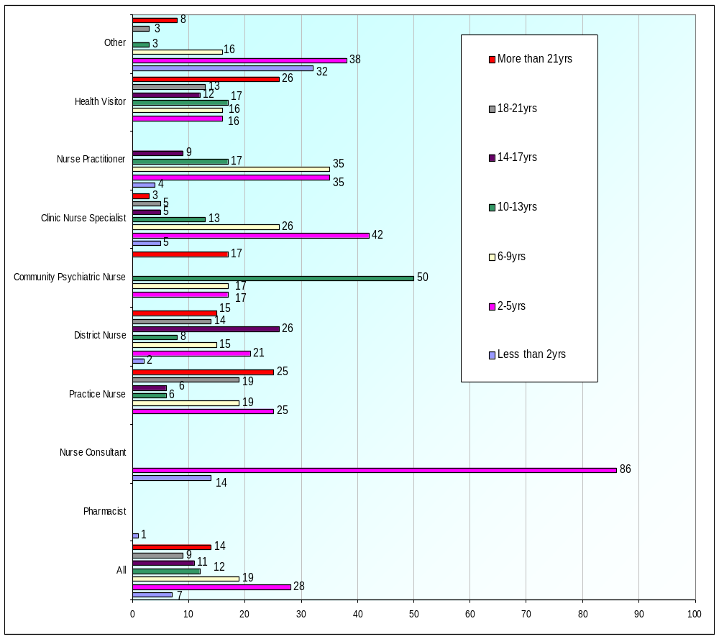

Figure 2. The length of service in present professional role.

4.3.2. How respondents are employed and pay scale on the Agenda for Change:
Only 3% of the respondents were in a job-share scheme (n= 8), and one was a ‘bank’ nurse. All the others were either full-time (52.2%; n = 141) or part-time (44.4%; n = 120). The nurse prescribers were generally ‘G’ grade (50%; n = 135), ‘H’ grade (24.1%; n = 65) or ‘I’ grade (4.4%; n = 12). There was a small minority of other known nursing grades (‘E’ n = 2; ‘F’ n = 2), although 14.4% of respondents did not appear to know what grade they were on, or failed to complete this section.
With respect to pay scales, the numbers (% of respondents) generally reflected nursing grades:

Agenda for Change 5: 1%
Agenda for Change 6: 69%
Agenda for Change 7: 83%
Agenda for Change 8a: 11%
Agenda for Change 8b: 5%
Agenda for Change 8c: 1%

4.3.3. Qualifications of the non-medical prescribers: Qualifications varied depending on their respective original professional roles (see Table 3). The pharmacist had an MPharm degree, and 85.7% of the nurse consultants who were questioned had a Masters degree.

Table 4. General Qualifications of Respondents to the Questionnaire

 | All | Pharmacist | Nurse Consultant | Practice Nurse | District Nurse | Community Psychiatric Nurse | Clinic Nurse Specialist | Nurse Practitioner | Health Visitor | Other
N | 270 | 1 | 7 | 16 | 66 | 6 | 38 | 23 | 76 | 37
RGN | 90% | - | 100% | 100% | 91% | - | 89% | 83% | 92% | 100%
RMN | 6% | - | - | - | 2% | 100% | 5% | 4% | 5% | 5%
DipHE RN (M) | 0% | - | - | - | - | - | - | - | 1% | -
DipHE RN(Adult) | 3% | - | - | - | 5% | - | 3% | 4% | 1% | 8%
DN | 40% | - | - | 50% | 92% | - | 29% | 9% | 7% | 59%
HV | 33% | - | 29% | 19% | - | - | 11% | 9% | 95% | 19%
Certificate | 23% | - | 43% | 25% | 24% | - | 26% | 22% | 18% | 27%
Diploma | 39% | - | 43% | 44% | 30% | 33% | 53% | 35% | 39% | 43%
Degree | 50% | 100% | 57% | 31% | 50% | 67% | 45% | 78% | 49% | 46%
Masters | 7% | - | 86% | - | 2% | - | 11% | - | 5% | 14%
Post-grad Diploma | 10% | 100% | 14% | - | - | 50% | 11% | 9% | 14% | 11%
MPharm | 0% | 100% | - | - | - | - | - | - | - | -
Other | 16% | - | 29% | 13% | 6% | 17% | 16% | 26% | 24% | 14%

4.3.4. Nature of the qualifications awarded in order to be eligible to prescribe: Some of the respondents had more than one prescribing qualification (hence percentages here add up to >100%). Of those questioned 72% had the NMC V100, 34% had mentor qualifications, 22% had the Extended Formulary + Supplementary Prescribing (NMC V300), and 13% were Extended Formulary Nurse Prescribers (NMC V200). Only 6% were supplementary prescribers and this includes the one pharmacist who replied. The 36% who possessed a teaching qualification were mainly nurse consultants, clinical nurse specialists and nurse practitioners (see Table 4).

Table 5: Prescribing qualifications of respondents to the questionnaire

 | All | Pharm-  acist | Nurse Consultant | Practice Nurse | District Nurse | Community Psychiatric Nurse | Clinic Nurse Specialist | Nurse Practitioner | Health Visitor | Other
N | 270 | 1 | 7 | 16 | 66 | 6 | 38 | 23 | 76 | 37
Mentor Qualifications | 34% | - | 43% | 6% | 44% | 83% | 42% | 39% | 24% | 27%
Extended Formulary Nurse Prescribers  (NMC V200) | 13% | - | 29% | 19% | 8% | - | 18% | 52% | 5% | 8%
Extended Formulary plus Supplementary Nurse  (NMC V300) | 22% | - | 57% | 31% | 6% | 67% | 42% | 61% | 3% | 27%
Supplementary Prescriber (inc pharmacists) | 6% | 100% | 14% | 13% | - | - | 8% | 30% | - | 3%
Nurse Prescriber - DN and HV  (NMC V100) | 72% | - | 29% | 50% | 98% | - | 42% | 17% | 93% | 78%
Teaching Qualification | 36% | - | 43% | 13% | 23% | 33% | 47% | 39% | 36% | 54%
None | 1% | - | - | 6% | 2% | - | - | - | 1% | 3%

4.3.5. Time taken to qualify: The time taken to qualify is a significant issue for the health service and this data is shown in Figure 3.

Nurse Prescriber (NMC V100): a significant number in each group generally it took up to five years to qualify.

Extended Formulary + Supplementary Prescriber (NMC V200) it took most up to three years.

Extended Formulary + Supplementary Prescriber (NMC V300), the time taken to qualify was around 12 months.

Supplementary prescribers (including the pharmacist), it took around 2 years for them to qualify.

Detailed graphs representing the time frame to qualify per qualifications and by job title are available in appendix (see Figures A1, A2, A3 and A4).

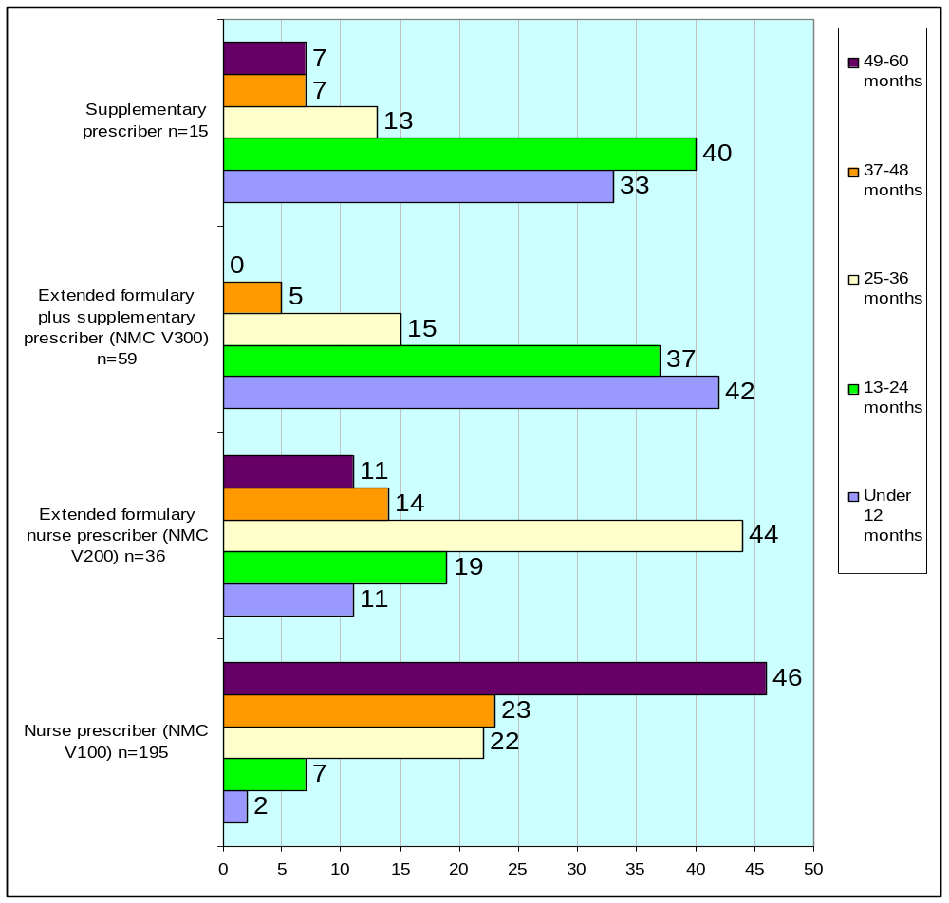

Figure 3. Summary of the time taken to qualify by individual qualification

4.3.6. Where the non-medical prescribers studied: As far as where the respondents qualified in non-medical prescribing, the Universities of Surrey and Brighton were the main institutions that offered the CPD for all four types of prescribing courses (see Figure 4). University of Surrey provided education for more respondents who studied on the Extended Formulary + Supplementary Prescriber courses (NMC V300 and NMC V200). The ‘others’ represents other HE institutes, for example, Universities of Reading, Winchester and South Bank.


50
44
25
47
50
53
68
47
25
3
7
7
0
10
20
30
40
50
60
70
80
Nurse prescriber (NMC
V100) n=195
Extended formulary nurse
prescriber (NMC V200)
n=36
Extended formulary plus
supplementary prescriber
(NMC V300) n=59
Supplementary prescriber
n=15
Other*
Surrey
Brighton

Figure 4. Summary of the location of HEI where qualifications were awarded

4.3.7. Appropriateness of the programmes of study: With respect to appropriateness of their programmes of study, 86% respondents answered ‘Yes’ to the question. The remaining 14% who answered ‘No’ suggested the courses were generic rather than related to practice, without enough emphasis on pharmacology. It could be argued that courses need to be generic owing to the wide scope of practice represented in the student population (see Table 3).

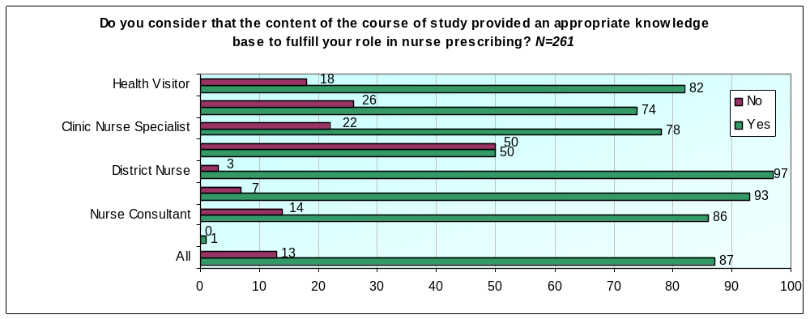

Figure 5. Appropriate knowledge base in the course studied to fulfill the role in non-medical prescribing (n = 261]

4.3.8. Confidence in prescribing: A key issue when embarking and maintaining a new skill is:
1. Being able to apply knowledge gained from the programme of study completed, and
- The importance of personal confidence in performance.

The vast majority of respondents, irrespective of roles, felt that the content of the courses studied provided an appropriate knowledge base to fulfill their role in non-medical prescribing (see Figure 5) and were confident in their abilities to prescribe (see Figure 6) as they were able to apply knowledge gained.

Confidence was a significant issue for respondents in being able to perform as a non-medical prescriber (see Table 6 that provides the qualitative data from those questioned). Briefly, the extremely confident and fairly confident non-medical prescribers appear to have the self-confidence to prescribe within their clinical specialty and were:
- Prepared to keep up-to-date by studying and checked out aspects of their prescribing
- Prescribed within their own professional boundaries,
- Communicating with colleagues who were approachable and supportive.

The respondents who were less confident in non-medical prescribing attributed this to:
- A lack of knowledge, experience and confidence;
- Never having prescribed and needing updating;
- Having insufficient support from colleagues.

Table 6. Replies to the statement on respondents’ confidence in non-medical prescribing:

Extremely confident (n=23)
I work and prescribe only in my area of competency (n=10)
I am confident in my specialty (n=4)
I read and understand the research in my field (n=3)
I have a good knowledge of what I can prescribe safely (n=2)
I keep up to date ‘researching’ any areas where I feel my knowledge is lacking (n=2)
I communicate with my colleagues (n=2)

Fairly confident (n=48)
I am happy with what I prescribe (n=17)
I only prescribe within my boundaries (n=13)
There is always room for improvement and opportunities to learn more (n=5)
Colleagues are approachable and supportive (n=4)
I still need to refer to the BNF at times (n=3)
‘Practice makes perfect’ (n=1)
Insufficient practical experience in current role, not using my prescribing role very often, feel I need more experience (n=5)

Neither confident nor unconfident (n=10)
I limit my areas of prescribing to conditions I feel competent to treat (n=2)
I have not been given the opportunity to prescribe (n=4)
I am an experienced prescriber in the limited range available to me (n=2)
I need to be prescribing more regularly to be confident (n=2)

Fairly unconfident (n=7)
Sometimes I have to double check what I can prescribe (n=2)
Insufficient back–up and support from colleagues and GPs (n=2)
Lack of knowledge, experience and confidence (n=3)

Extremely unconfident (n=2)
Have never prescribed and need updating (n=1)
Training did not prepare me (n=1)

4.3.9. Non-medical prescribing enhances the professional role: Being able to prescribe tended to improved job satisfaction by enhancing the professional role in 84% of non-medical prescribers questioned (see Table 7 that provides the qualitative data from those questioned). Briefly, comments on job satisfaction attributed this to the following:

- A feeling of autonomy that also gives confidence to the patients;
- Appropriate treatment at point of contact;
- Seamless and holistic care for patients;
- Saving time for all patient and non medical prescribers and not chasing the doctor for a prescription.

Unsurprisingly, the respondents who did not feel prescribing enhanced their role were those who rarely actually prescribed, or used a limited formulary of over the counter drugs.

Table 7. Replies to the statement:

‘Non-medical prescribing enhances my professional role’

Strongly agree (n=75)
The comments of those who strongly agreed fell into the following themes:

Speeds up treatment for patients and therefore saves time (n= 10)
Improves patient care (n=8)
Provides holistic care (n=14)
Allows me to work autonomously and it enhances my role (n=14)
Creates a ‘one stop’ clinic and a complete package of care for patients (n=10)
Being able to prescribe speeds up the patient’s journey (n=5)
You are more accountable for your actions (n=4) ‘rather than hide behind the GP signature’
No need to go to the GP (n=5)
Convenient for me and the patient (n=3)
Gives confidence to patients (n=2)

Agree (n=66)
When I have a chance to prescribe it enhances and provides a better quality of care (n=10)
Saves the patient time (n=9)
Not chasing the GP for a prescription (n=10)
Gives me autonomy (n=6)
Allows seamless care (n=6)
Provides more holistic care (n=5)
It allows me to provide patients with appropriate treatment at point of contact (n=7)
Allows me to be more efficient in my role (n=5)
Gives confidence to patients (n=4)
Saves time (n=4)

141 respondents either strongly agreed or agreed to the statement ‘The role of the prescriber enhances my professional role’ with only 7 respondents having no view on the statement.

Neither agree nor disagree (n=7)
It has had little impact on my professional role (HV) (n=1)
Little opportunity to prescribe (n=3)
What I prescribe can be bought over the counter (n=1)
Time saving (n=1)
Convenience to client (n=1)

Disagree
I do not prescribe due to limited formulary

Strongly disagree
No comments for this box
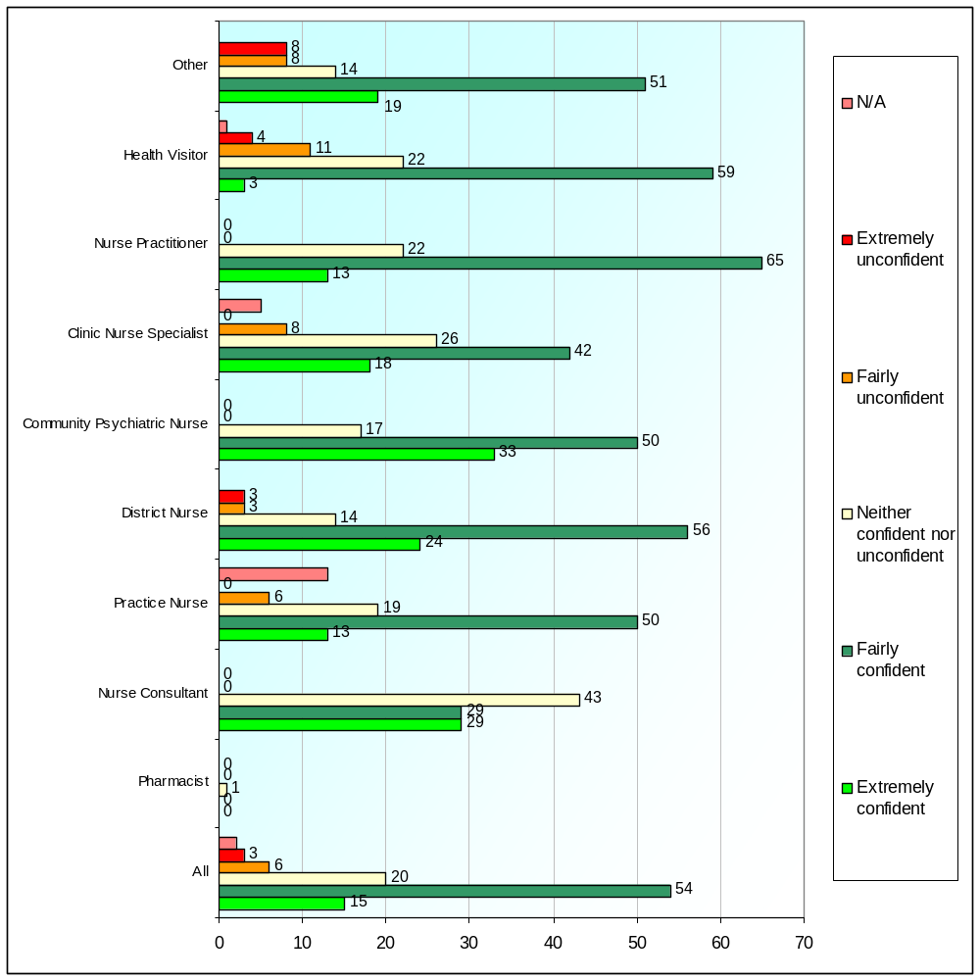

Figure 6. Confidence as a non-medical prescriber:

4.3.10. Length of service in practice area: Confidence comes with experience, hence we asked the question, ‘How long have you been practicing in your specialist area?’ For the majority or respondents, this had been for more than 5 years (see Table 5). Of the 12 respondents who had been in post for less than one year, 8 were district nurses and the other 4 were in the following specialties: care of the elderly, general practice, mental health or health visiting.

It varied as far as how often the respondents prescribe in a shift or span of duty alone (see Table 6). Only around 17% of respondents worked in collaboration with an independent medical prescriber to implement a clinical management plan (see Table 7).

Table 8. Length of service in practice area

Time | % & Number of Respondents
Under 12 months | 4.4% (n = 12)
13-24 months | 3.7% (n = 10)
25-36 months | 9.3% (n = 25)
37-48 months | 5.2% (n = 14)
49-60 months | 7.0% (n = 19)
More than 60 months | 70.4% (n = 190)

Table 9. How often respondents prescribe in their practice area

Frequency | % & Number of Respondents
Once during a span of duty | 24.4% (n = 66)
2-4 times per week | 17.0% (n = 46)
Once a week | 15.9% (n = 43)
Fortnightly | 6.7% (n = 18)
Monthly | 8.5% (n = 23)
Less than once a month | 13.3% (n = 36)
Not prescribed since qualifying | 5.6% (n = 15)
Not applicable | 8.5% (n = 23)

Table 10. Frequency with which respondents implemented a Clinical Management Plan with an Independent Medical Prescriber.

Frequency | % & Number of Respondents
Once during a span of duty | 1.5% (n = 4)
2-4 times per week | 3.7% (n = 10)
Once a week | 0.7% (n = 2)
Fortnightly | 1.1% (n = 3)
Monthly | 2.2% (n = 6)
Less than once a month | 8.5% (n = 23)
Not applicable | 82.2% (n = 222)

4.4. CONTINUING PROFESSIONAL DEVELOPMENT (CPD)
There is currently a strong belief that effective CPD can improve competence which in turn leads to increased job satisfaction and serves to enhance professionalisation. Yet only 29.3% of respondents were studying for a further academic qualification (n=79). Of those studying 48% were engaged in studies related to their specialist areas and only 5% were studying prescribing or pharmacology. Within the 79 respondents who were studying:

- 40.5% were on a Masters programme (n = 32)
- 30.4% were on a Bachelor degree programme (n = 24)
- 3.8% were on a Professional Doctorate programme (n = 3)
- 25.3% were doing CPD in the form of post-graduate diplomas or certificates (n = 20)

4.4.1. Course or programmes specific to clinical specialty: Of all respondents, 76% had attended a course or programme provided by their employer within the last 12 months, but the length of such courses varied:

Half-day 5% of respondents
One-day 26% of respondents
Two-day 19% of respondents
Three-day 22% of respondents
Four-day 5% of respondents
Five-day 23% of respondents

43% of respondents had attended courses provided by organisations other than their employers in the last 12 months and again, such courses or programmes appeared most likely to be of a varied duration:

Half-day 4% of respondents
One-day 30% of respondents
Two-day 30% of respondents
Three-day 15% of respondents
Four-day 8% of respondents
Five-day 14% of respondents

Some professional groups (i.e. Community Psychiatric Nurses [17%], District Nurses (24%], Health Visitors [36%]) were less likely to attend these events than those provided by their employers. An interesting exception was the Clinical Nurse Specialists who indicated they were more likely to attend an event provided by an organisation other than their employer (79% compared with 57%]. See Figure 7 for a graph of completion of courses or programmes of study (specific to clinical specialty) within the last 12 months provided by employer and other organisations.

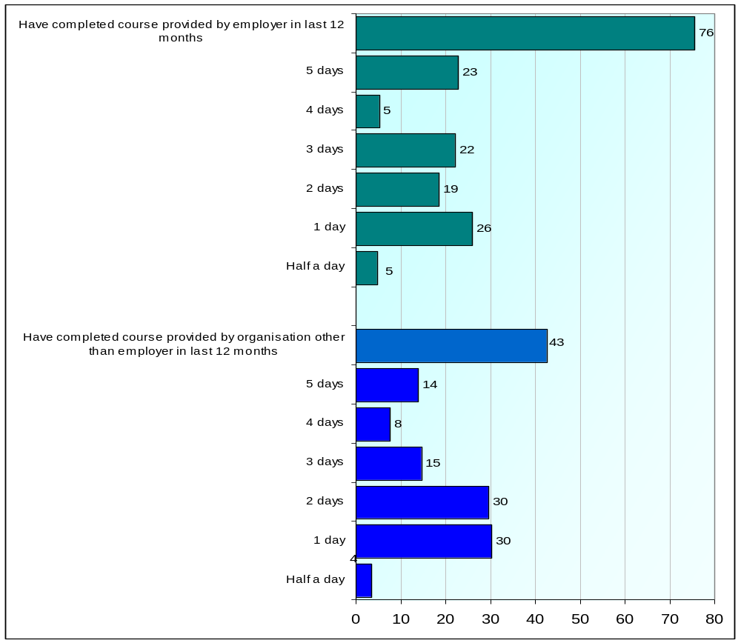

Figure 7. Completion of courses or programmes of study (specific to your clinical specialty) within the last 12 months provided by employer and other organisations (N = 270) and duration of course or programme provided by employer (N = 204) and other organisations (N = 115)

4.4.2. Mandatory study days provided by their employer: These had been attended by 83% of respondents in the last 12 months. As far as the duration of such courses:

Half-day 12% of respondents
One-day 29% of respondents
Two-day 29% of respondents
Three-day 18% of respondents
Four-day 5% of respondents
Five-day 8% of respondents

Attendance at these events with respect to specialist nurse included >50% of Community Psychiatric Nurses, with particularly high attendance among Practice Nurses (88%), Health Visitors (92%) and District Nurses (91%). The one pharmacist and seven nurse consultants indicated a 100% attendance.

Respondents were also asked about their attendance at a mandatory course or programme provided by an organisation other than their employer within the last 12 months. Respondents indicated that only 8% had attended such courses with the most likely duration being one (46%) or half a day (36%). See Figure 8 for details of length of mandatory courses (employer and non-employer programmes) attended by respondents.

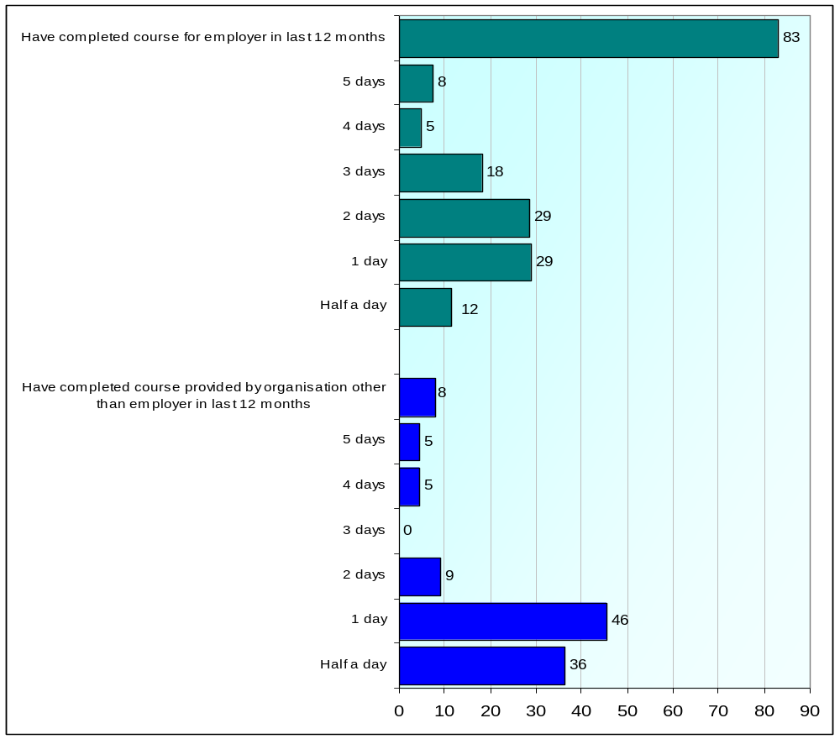

Figure 8. Completion of courses or programmes of mandatory study within the last 12 months provided by employer and other organisations (N = 270) and duration of course or programme provided by employer (N = 224) and other organisations (N = 22).

4.4.3. Specific to your role as a non-medical prescriber provided by the employer: Only 39% of respondents had attended short courses specific to their role within the last 12 months. As far as the duration of such courses:

Half-day 27% of respondents
One-day 44% of respondents
Two-day 14% of respondents
Three-day 8% of respondents
Four-day 3% of respondents
Five-day 4% of respondents

With the exception of the one pharmacist, attendance appeared to be 41% or less for all professional groups with only one (14%) of the seven consultant nurses indicating attendance at these events.

4.4.4. Specific to your role as a non-medical prescriber provided by an organisation other than the employer: Only 13% of respondents had attended short courses specific for their role within the last 12 months. As far as the duration of such courses:

Half-day 8% of respondents
One-day 53% of respondents
Two-day 25% of respondents
Three-day 8% of respondents
Four-day 0% of respondents
Five-day 13% of respondents

With the exception of the pharmacist attendance appeared to be 33% or less for all professional groups with District Nurses (7.6%) and Health Visitors (2.6%) being least likely to attend these events provided by organisations other than their employers. See Figure 9 for graph of completion of courses or programmes specific to non-medical prescriber role within the last 12 months provided by employer and other organisations.

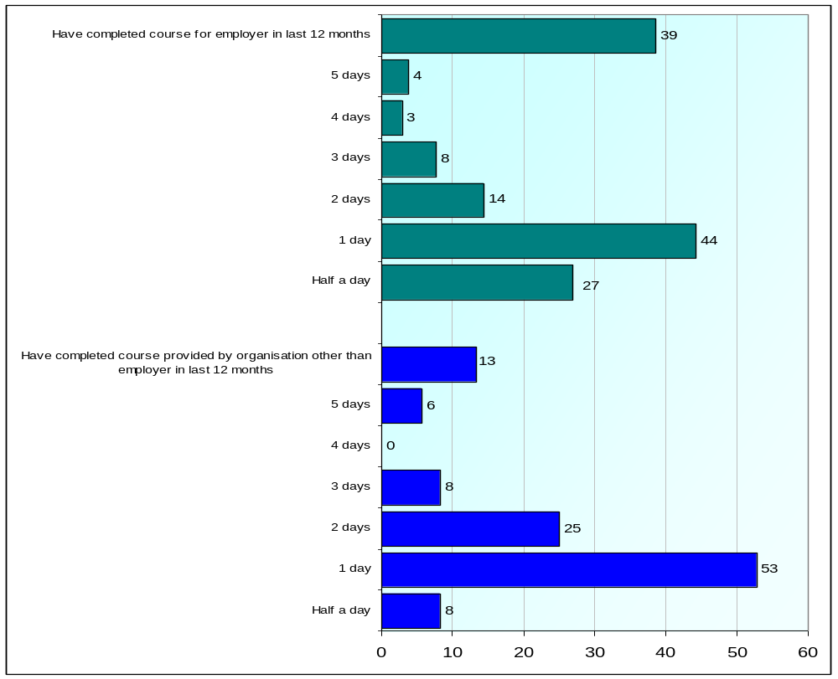

Figure 9. Completion of courses or programmes specific to non-medical prescriber role within the last 12 months provided by employer and other organisations (N = 270) and duration of course or programme provided by employer (N = 104) and other organisations (N = 36)

4.4.5. Attendance at conferences on non-medical prescribing within the last 12 months: Figure 10 shows that only 13% and 9% of respondents respectively, attended conferences on non-medical prescribing organised by their employers (13%) or another organisation (9%). One day was the most likely duration of the conference organised by both organisations. With the exception of the pharmacist who attended a conference organised by both organisations, the attendance by all other professional groups was relatively low. Percentages ranged from 9%-34% (employer organised conference) and 4%-29% (conference organised by other organisation) with the notable exception of 67% attendance reported by the community psychiatric nurses. However, as this was a small group of only six respondents, the findings should be interpreted with caution.

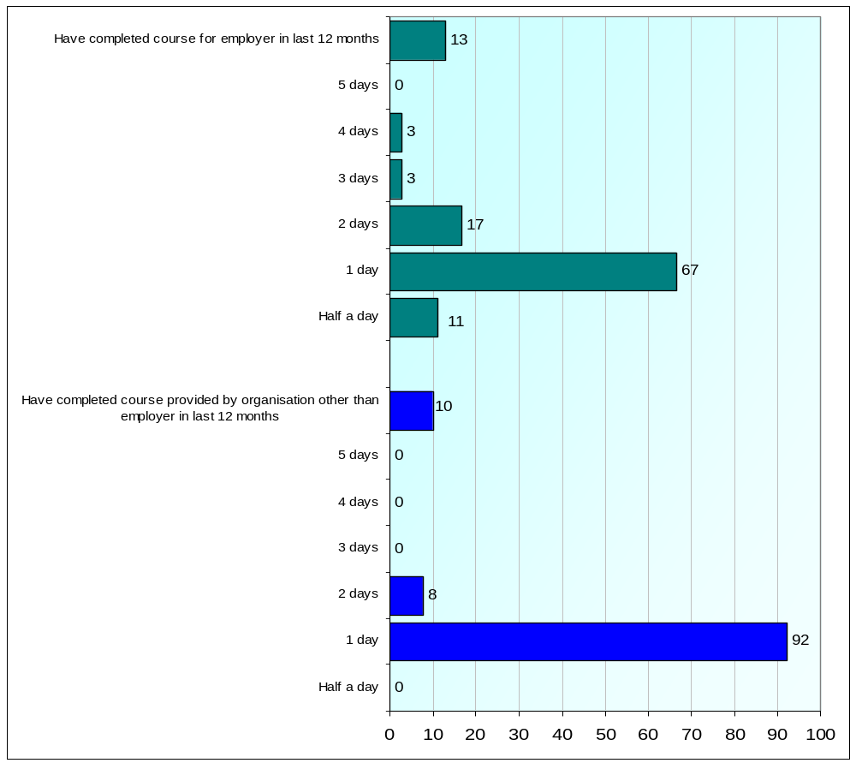

Figure 10. Conferences attended on non-medical prescribing within the last 12 months provided by employer and other organisations (N = 270) and duration of course or programme provided by employer (N = 36) and other organisations (N = 26)

4.4.6. National Conferences: Of the 270 respondents, only 57 completed this section. They reported that they had attended national conferences on prescribing, and there was mixed response when questioned whether they were able to apply to practice the information received (see Table 11 which provides the qualitative data from those questioned). Briefly the benefits of the conferences were:
- Consolidation of learning from previous courses studied;
- Information on new skills, e.g. electronic-generated prescriptions;
- Sharing with colleagues.
Where there was less satisfaction with conferences, this was attributed to
- Lack of workshops in appropriate subjects,
- Conference was pitched at an inappropriate level (academic or practice-based);
- Local policies on prescribing.

There appeared to be some uncertainty regarding the difference between what was a national conference, Surrey and Sussex SHA conference, workshop and study day(s). Many of the respondents used the terms ‘conference’, ‘study days’ and ‘workshops’ interchangeably. This could have been owing to CPD events attended including a range of different activities.

Many of the respondents were unable to provide details of the conference they had attended. But this may be because they were unable to distinguish between national and local strategic health authority organised conferences, especially if a conference was organised by the Surrey and Sussex SHA, but held in central London. Another reason might be that some did not know who the conference organisers were.

Table 11. Attendance at Conferences
Replies to the statement: ‘I was able to apply what I learnt to my practice.’
Agree
Consolidated what I had learned on the course.
I am progressing electronic generated prescriptions – did not know about this development prior to the conference.
The information I gained provided information to share with others and increased my knowledge of evidence based practice and prescribing in general.

Neither agree nor disagree
The conference was more about recruiting to future courses which I had already done.
Lack of workshops in the field of mental health.

This is relatively new in mental health where I work. Trust policy is still being agreed. Systems have yet to be put in place.
Most of the day was predominantly for GP practice/community nurses.

Disagree
As I have just completed the extended nurse prescribing course I did not gain very much from the conference. I found the conference was more suitable for people thinking of going on the extended course.
More interesting for those considering the course, not those with the qualification.
It was too repetitive and nothing new was presented.
It was about getting people on the course.

4.4.7. Attendance at a Surrey and Sussex SHA conference within the last 12 months: The following responses were obtained from specific questions about Surrey and Sussex SHA provision. Those who attended the in-house study day with pharmacists, exploring polypharmacy at Queen Elizabeth II Conference Centre, London considered this worthwhile. Responses included:
- Helped me to use supplementary prescribing covered within the supplementary prescribing course.
- At the conference in Horley (2005) – information was relevant to area of practice.
- SHA conference on the law of prescribing (an update) was not clinical.

In particular the conferences that were subject-specific proved to be the most popular and beneficial in providing a practical focus (see Table 12 for qualitative data from those questioned), for example the workshops on:
- Eczema and skin updates
- Diabetes
- Hypertension
- Infections and antibiotics
- Legal issues relating to prescribing
- Prescribing update
- Interpreting statistics in order to understand pharmaceutical co-mpany data

Table 12. Replies to the statement:

Conferences where topics were applicable to the non-medical prescribers’ Practice

Strongly agree
High standard of teaching appropriate for extended prescribers (locally run workshop days)
Heightened my awareness of management of hypertension using evidence based practice (locally run workshop days)
Prescribing for diabetic patients – clinically appropriate
Nurse Prescriber training for nurses provided by the Surrey & Sussex SHA. Content and presentation very practically focussed.
Eczema and skin update – for Nurse Prescribers – vital for updating or best practice and correct advice.
Eczema and skin update – for Nurse Prescribers. First time I have understood principles of eczema treatment
Update for Nurse Prescribers – very informative, very well presented, uptodate information - made me feel more confident in prescribing.
Workshop on common acute infections – relevant information to practice.
Skin and antibiotic workshop Nurse Prescribers Centre – updates. Excellent information, presentation and sharing.
Hypertension NP centres – I only prescribe for hypertension patients – learned several new things.
MSc module on Medicine management – practice up to date (City University)
Prescribing update – gave me confidence and took the fear out of prescribing.

Agree
National Prescribing Centre Hypertension workshop – I was able to implement what I had learned.
Interpreting statistics – the course enabled me to analyse any pharmaceutical companies’ data more effectively.
Infection and antibiotics – clinically based but not all relevant to my area of practice.
Skin conditions workshop – gave me an update on products available and recent research.
Legal issues – relevant to practice.
NP workshops – speakers were informative and challenging which then allowed grey areas to be explored. Explanations of how we could use the gained knowledge in our practice.

Neither agree nor disagree
Dermatology workshop – mainly to do with skin complaints but not relevant to the majority of my practice.
Antibiotics, pain, hypertension study days (SHA workshops) – I would have stated ‘strongly agree’ if I was able to actually use the qualification (as a prescriber).

Disagree
Non-medical prescribing event – no new information – some not specific to HV.
London conference - I did not learn anything but made some contacts.

Strongly disagree
Workshop on prescribing antibiotics in ENT – the content was not useful and not what I was led to believe.

Of particular significance were the respondents who had attended a course or programme specific to prescribing organised by the Surrey and Sussex SHA within the last 12 months to assess the extent to which they were able to apply what they had learnt to practice. These results are shown in Figure 11. This figure shows that there appears to be overwhelming agreement by all professional groups with the exception of the Community Psychiatric Nurses that they had been able to apply their study to practice.

35
50
10
0
44
43
44
36
49
0
33
75
0
33
57
40
50
11
0
17
10
22
0
12
0
5
0
0
5
0
0
0
4
14
100
100
0
20
40
60
80
100
All
Pharmacist
Practice Nurse
District Nurse
Community Psychiatric
Nurse
Clinic Nurse Specialist
Nurse Practitioner
Health Visitor
Other
Disagree
Neither agree
nor disagree
Agree
Strongly agree

Figure 11. Surrey and Sussex SHA course or programme of study attended during the last 12 months: "I was able to apply what I learnt to my practice" (by current job title)
(N = 83)

4.4.8. ‘Please rank your prescribing continuing professional development needs in order of importance.’

NB: This question related to participants’ un-met CPD needs.

(a) Nature of subjects required as CPD for the non-medical prescribers:
The respondents rated their preferences for the main CPD subjects required from 1 - 10. The mean score (out of 10) for each element of this question was calculated and has been expressed as R (where R is the mean response of all respondents, and where 1 = most preferred; and 10 = least preferred).

The needs of the different respondents varied, but the main subject areas that they believed warranted CPD were:

Patient/Client assessment | R = 4.31
Non-medical prescribing information | R = 4.70
Support for experienced non-medical prescribers | R = 4.76
Decision-making skills | R = 4.91

There was diversity, with some wanting and others disinclined in the following areas:

Drug/Pharmacology Law | R = 5.09
Principles of Pharmacology | R = 5.25

The following areas were not as highly recommended as subject areas for CPD:

Drug administration | R = 5.39
Physiology | R = 5.47
Psychopharmacology | R = 5.91
Biological Sciences | R = 6.33

(b) ‘How would you prefer to gain your continuing professional experience?’ (i.e. mode of delivery)
Again, as above, this question asked the participants to consider their unmet needs.

Mode of delivery of CPD
The respondents rated their preferences for mode of delivery from 1 - 10. The mean score (out of 10) for each of the elements of this question was calculated and has been expressed as R (where R is the mean response of all respondents, and where 1 = most preferred ; and 10 = least preferred).

The general trend was that they preferred face-to-face and practice-focused delivery of learning:

Training days | R = 3.47
Short courses | R = 3.77
In-practice setting | R = 3.78
Lectures | R = 4.80

They considered the following modes of delivery to be less favourable:

Self-directed learning | R = 6.28
E-learning | R = 6.32
Distance learning | R = 6.59

Since these are aggregated data, they can only display trends. More detailed information on the responses to need with respect to nature of CPD in relation to professional roles, and its mode of delivery can be found in tabulated form below.

(c) Data on CPD needs and mode of delivery of education by professional group
There were very mixed responses between and within each professional group. Regarding the data found within the tables 13 - 30 (see below), given the small numbers in each group, it would be expedient to view any findings as general trends and thus to interpret with caution. However, it would seem that some subject areas and modes of delivery of CPD were rated as a higher priority by certain groups.
(i) Nature of subjects required as CPD for the non-medical prescribers:
Within the following tables (Table 13 - 22 inclusive) are the mean scores on weighting of need for the respective subjects relating to professional roles of the non-medical prescribers who were surveyed. (1 = most preferred; and 10 = least preferred). The mean of the total for each subject area surveyed has been recorded in section (a) above as ‘R’.

Table 13. Principles of pharmacology

Current Job Title | Mean | N | Std. Deviation
Nurse Consultant | 3.71 | 7 | 1.799
Community Psychiatric Nurse | 3.83 | 6 | 3.817
Nurse Practitioner | 4.61 | 23 | 3.041
District Nurse | 4.64 | 66 | 2.582
Clinic Nurse Specialist | 4.74 | 38 | 3.577
Practice Nurse | 5.75 | 16 | 2.887
Health Visitor | 5.95 | 76 | 3.162
Other | 6.05 | 37 | 3.527
Pharmacist | 9.00 | 1
Total | 5.25 | 270 | 3.155

Table 14. Drug administration

Current Job Title | Mean | N | Std. Deviation
Nurse Consultant | 3.71 | 7 | 2.752
Nurse Practitioner | 4.43 | 23 | 2.952
Clinic Nurse Specialist | 4.97 | 38 | 3.590
District Nurse | 5.09 | 66 | 3.127
Health Visitor | 5.43 | 76 | 3.446
Practice Nurse | 5.81 | 16 | 3.487
Other | 6.49 | 37 | 3.679
Community Psychiatric Nurse | 7.83 | 6 | 4.579
Pharmacist | 9.00 | 1 | .
Total | 5.39 | 270 | 3.433

Table 15. Patient/client assessment

Current Job Title | Mean | N | Std. Deviation
Pharmacist | 3.00 | 1 | .
District Nurse | 3.48 | 66 | 3.004
Nurse Practitioner | 4.09 | 23 | 3.423
Health Visitor | 4.28 | 76 | 3.474
Clinic Nurse Specialist | 4.34 | 38 | 3.878
Nurse Consultant | 4.43 | 7 | 3.645
Practice Nurse | 5.00 | 16 | 3.596
Other | 5.32 | 37 | 4.117
Community Psychiatric Nurse | 6.33 | 6 | 4.885
Total | 4.31 | 270 | 3.570

Table 16. Non-medical prescribing information

Current Job Title | Mean | N | Std. Deviation
Nurse Consultant | 3.14 | 7 | 2.545
Clinic Nurse Specialist | 4.13 | 38 | 3.512
Nurse Practitioner | 4.22 | 23 | 3.288
District Nurse | 4.27 | 66 | 2.917
Health Visitor | 4.64 | 76 | 3.261
Other | 5.68 | 37 | 3.808
Practice Nurse | 5.88 | 16 | 3.222
Community Psychiatric Nurse | 7.50 | 6 | 4.278
Pharmacist | 10.00 | 1 | .
Total | 4.70 | 270 | 3.357

Table 17. Physiology

Current Job Title | Mean | N | Std. Deviation
Pharmacist | 3.00 | 1 | .
Nurse Consultant | 3.71 | 7 | 1.496
Nurse Practitioner | 4.52 | 23 | 2.661
District Nurse | 4.79 | 66 | 2.692
Clinic Nurse Specialist | 5.21 | 38 | 3.322
Practice Nurse | 5.50 | 16 | 3.011
Other | 5.95 | 37 | 3.613
Health Visitor | 6.25 | 76 | 3.047
Community Psychiatric Nurse | 7.83 | 6 | 3.817
Total | 5.47 | 270 | 3.105

Table 18. Psychopharmacology

Current Job Title | Mean | N | Std. Deviation
Nurse Consultant | 4.43 | 7 | 1.397
Nurse Practitioner | 4.70 | 23 | 3.052
Community Psychiatric Nurse | 4.83 | 6 | 3.430
Practice Nurse | 5.13 | 16 | 3.160
Clinic Nurse Specialist | 5.50 | 38 | 3.286
District Nurse | 5.76 | 66 | 2.845
Pharmacist | 6.00 | 1 | .
Other | 6.43 | 37 | 3.132
Health Visitor | 6.76 | 76 | 3.015
Total | 5.91 | 270 | 3.064

Table 19. Biological sciences

Current Job Title | Mean | N | Std. Deviation
Nurse Practitioner | 4.70 | 23 | 2.819
Pharmacist | 5.00 | 1 | .
Nurse Consultant | 5.43 | 7 | 2.820
District Nurse | 5.53 | 66 | 2.696
Practice Nurse | 5.75 | 16 | 2.745
Clinic Nurse Specialist | 6.39 | 38 | 3.098
Other | 7.03 | 37 | 3.201
Health Visitor | 7.25 | 76 | 2.757
Community Psychiatric Nurse | 7.67 | 6 | 3.445
Total | 6.33 | 270 | 2.969

Table 20. Decision-making skills

Current Job Title | Mean | N | Std. Deviation
Pharmacist | 4.00 | 1 | .
Nurse Practitioner | 4.17 | 23 | 3.312
Nurse Consultant | 4.29 | 7 | 3.592
District Nurse | 4.39 | 66 | 3.073
Practice Nurse | 4.69 | 16 | 3.439
Clinic Nurse Specialist | 4.95 | 38 | 3.639
Health Visitor | 5.18 | 76 | 3.373
Community Psychiatric Nurse | 5.50 | 6 | 3.937
Other | 5.86 | 37 | 3.780
Total | 4.91 | 270 | 3.406

Table 21. Drug/pharmacology law

Current Job Title | Mean | N | Std. Deviation
Pharmacist | 4.00 | 1 | .
District Nurse | 4.42 | 66 | 2.993
Nurse Consultant | 4.43 | 7 | 3.994
Clinic Nurse Specialist | 4.63 | 38 | 3.404
Community Psychiatric Nurse | 5.00 | 6 | 4.050
Nurse Practitioner | 5.13 | 23 | 2.928
Practice Nurse | 5.38 | 16 | 2.918
Health Visitor | 5.58 | 76 | 3.575
Other | 5.73 | 37 | 3.493
Total | 5.09 | 270 | 3.328

Table 22. Support for experienced prescribers

Current Job Title | Mean | N | Std. Deviation
Nurse Consultant | 3.43 | 7 | 2.820
District Nurse | 4.23 | 66 | 2.976
Nurse Practitioner | 4.43 | 23 | 3.217
Health Visitor | 4.68 | 76 | 3.681
Clinic Nurse Specialist | 4.87 | 38 | 3.663
Practice Nurse | 5.44 | 16 | 3.596
Other | 5.70 | 37 | 3.658
Community Psychiatric Nurse | 5.83 | 6 | 4.215
Pharmacist | 6.00 | 1 | .
Total | 4.76 | 270 | 3.455

(ii) Mode of delivery of CPD
Within the following tables (Table 23 - 30 inclusive) are the mean scores on weighting of preferred mode of delivery of CPD relating to professional roles of the non-medical prescribers who were surveyed. (1 = most preferred; and 10 =
least preferred). The mean of the total for each mode of delivery of CPD surveyed has been recorded as ‘R’ in section (b) above. As previously noted the numbers represented are too small to draw any clear conclusion.

Table 23. Distance learning

Current Job Title | Mean | N | Std. Deviation
Pharmacist | 1.00 | 1 | .
Clinic Nurse Specialist | 5.63 | 38 | 3.460
Nurse Practitioner | 6.04 | 23 | 3.254
Practice Nurse | 6.06 | 16 | 3.130
Nurse Consultant | 6.14 | 7 | 3.671
District Nurse | 6.30 | 66 | 3.191
Community Psychiatric Nurse | 6.50 | 6 | 4.037
Health Visitor | 7.64 | 76 | 3.224
Other | 6.70 | 37 | 3.597
Total | 6.59 | 270 | 3.374

Table 24. E-Learning

Current Job Title | Mean | N | Std. Deviation
Clinic Nurse Specialist | 4.68 | 38 | 3.120
Nurse Practitioner | 5.09 | 23 | 2.859
Practice Nurse | 5.69 | 16 | 3.156
Pharmacist | 6.00 | 1 | .
Nurse Consultant | 6.29 | 7 | 3.546
Other | 6.32 | 37 | 3.528
Community Psychiatric Nurse | 6.33 | 6 | 4.546
District Nurse | 6.50 | 66 | 3.050
Health Visitor | 7.49 | 76 | 3.202
Total | 6.32 | 270 | 3.305

Table 25. Lectures

Current Job Title | Mean | N | Std. Deviation
Pharmacist | 1.00 | 1 | .
Nurse Practitioner | 3.96 | 23 | 3.097
Nurse Consultant | 4.00 | 7 | 2.236
District Nurse | 4.38 | 66 | 2.816
Clinic Nurse Specialist | 4.58 | 38 | 3.350
Health Visitor | 5.17 | 76 | 3.336
Practice Nurse | 5.31 | 16 | 3.610
Other | 5.41 | 37 | 3.663
Community Psychiatric Nurse | 5.83 | 6 | 4.355
Total | 4.80 | 270 | 3.262

Table 26. Conferences

Current Job Title | Mean | N | Std. Deviation
Nurse Consultant | 4.29 | 7 | 1.704
Clinic Nurse Specialist | 4.61 | 38 | 3.453
Nurse Practitioner | 4.96 | 23 | 2.654
Practice Nurse | 5.06 | 16 | 3.130
District Nurse | 5.35 | 66 | 2.911
Health Visitor | 6.11 | 76 | 3.365
Other | 6.11 | 37 | 3.542
Community Psychiatric Nurse | 6.33 | 6 | 4.082
Pharmacist | 10.00 | 1 | .
Total | 5.52 | 270 | 3.234

Table 27. In the practice setting with colleagues

Current Job Title | Mean | N | Std. Deviation
Pharmacist | 3.00 | 1 | .
District Nurse | 3.03 | 66 | 2.542
Nurse Consultant | 3.43 | 7 | 2.440
Health Visitor | 3.54 | 76 | 3.109
Clinic Nurse Specialist | 4.13 | 38 | 3.086
Other | 4.35 | 37 | 3.788
Practice Nurse | 4.44 | 16 | 3.140
Nurse Practitioner | 4.52 | 23 | 3.160
Community Psychiatric Nurse | 5.17 | 6 | 4.579
Total | 3.78 | 270 | 3.116

Table 28. Short courses

Current Job Title | Mean | N | Std. Deviation
Pharmacist | 1.00 | 1 | .
District Nurse | 3.20 | 66 | 2.632
Health Visitor | 3.21 | 76 | 3.026
Nurse Consultant | 3.57 | 7 | 2.370
Nurse Practitioner | 3.83 | 23 | 2.887
Clinic Nurse Specialist | 4.50 | 38 | 3.711
Practice Nurse | 4.63 | 16 | 3.649
Community Psychiatric Nurse | 4.67 | 6 | 4.967
Other | 4.76 | 37 | 3.869
Total | 3.77 | 270 | 3.256

Table 29. Training days

Current Job Title | Mean | N | Std. Deviation
Pharmacist | 2.00 | 1 | .
District Nurse | 2.58 | 66 | 2.456
Nurse Practitioner | 3.00 | 23 | 2.812
Nurse Consultant | 3.43 | 7 | 3.780
Health Visitor | 3.59 | 76 | 3.073
Clinic Nurse Specialist | 3.71 | 38 | 3.179
Practice Nurse | 4.06 | 16 | 3.958
Other | 4.38 | 37 | 3.982
Community Psychiatric Nurse | 5.17 | 6 | 4.665
Total | 3.47 | 270 | 3.206

Table 30. Self-directed learning

Current Job Title | Mean | N | Std. Deviation
Pharmacist | 1.00 | 1 | .
District Nurse | 5.55 | 66 | 3.149
Nurse Consultant | 5.57 | 7 | 3.505
Practice Nurse | 5.63 | 16 | 2.941
Clinic Nurse Specialist | 6.11 | 38 | 3.509
Community Psychiatric Nurse | 6.17 | 6 | 4.167
Nurse Practitioner | 6.30 | 23 | 3.052
Other | 6.46 | 37 | 3.396
Health Visitor | 7.20 | 76 | 3.145
Total | 6.28 | 270 | 3.279

From these results it could be tentatively interpreted that e-learning and distance learning are the least preferred modes of learning whilst learning in the practice setting and short courses the most popular means of learning.

4.5. OPEN ENDED QUESTIONS
Of the 270 returned questionnaires 79 respondents used the open ended question section at the end of the questionnaire to provide further comments.

Four main themes were identified from the statements provided by the respondents:
- Demands for Continuing Professional Development (CPD)
- Support for CPD in practice
- Barriers to CPD
- Barriers to learning in practice.

4.5.1. Demands for CPD
50% of respondents commented on the importance of further support for non-medical prescribers through study days, conferences, e-learning and clinical supervision. Some respondents suggested that the study days/conferences should be mandatory and based locally in order to avoid too much travelling from the workplace. Suggested topics within the content of the study days was more physiology, physical assessment and pharmacology. There were also comments about giving sufficient notice of workshops, with some respondents highlighting the importance of needing to know months in advance of available study days (see Table
31).

Table 31. Comments on demands for continuing professional development (CPD)

One respondent
“My feelings are that you cannot prescribe safely and effectively unless you can make a patient assessment and have a thorough knowledge of pathophysiology of the disease as well as medication. Therefore all study should be disease pathophysiology and prescribing hand-in-hand.”

A clinical nurse specialist provided support stating:
“Needed more of physiology (back to basics) and basic pharmacology update. Felt I did not get to grips with this on the course…others felt the same.”

Other respondents commented:
“Constant updating essential.”
“Essential, should be mandatory” (echoed by a substantial minority)

One nurse consultant added:
“The one day workshops and networking meetings are excellent both in terms of information, but mostly for networking. Much more useful than going to London for big conferences.”

In relation to the comments made about pharmacology a community matron stated:
“…it is medication management and knowledge of interactions of poly pharmacy – most important…..Prescribing for the most frail with severe chronic diseases requires knowledge at medical level – even consultants struggle sometimes.”

A health visitor, however, offered a different perspective on CPD:
“The type of prescribing I do is mainly for thrush and head lice. I feel up-to-date and confident with that. I don’t feel the need for endless updating on something which has so little impact on my role.”

A clinical nurse specialist also moved away from the emphasis of provision by stating:
“I think as a nurse I have a responsibility to keep up-to-date by reading and researching.”

The pharmacist drew attention to the CPD needs of that profession and that they can end up being the provider of CPD for other professional groups and their own needs not being met:
“Please take into consideration the needs of pharmacists as well as nurses as pharmacists seem to be less priority in training needs. We normally end up doing/presenting the training for the nurse prescribers!”

4.5.2. Support for CPD in practice
10% of respondents identified the importance of support in the practice settings, with a number indicating that they already received support from medical colleagues, peer groups and managers within their specialist practice areas. They also commented on the utility of regular contact suggesting that it could be further developed (see Table 32).

Table 32. Comments on support for CPD in practice

One respondent:
“I like to discuss experiences with other health visitors and practice nurses.”

Two health visitors identified
“Need to sit in on consultations with other prescribers.”
”Need an ongoing programme of development in order to keep up-to-date. Also useful to meet with other prescribers and to look at individuals prescribing practices.”

A district nurse commented on the demands of the job in relation to CPD requirements:
“Whilst continuing professional development is necessary competition with non-prescribing development needs, demands of workplace, part-time hours etc make it difficult to find time for courses. More opportunities for learning ‘in the workplace’ would be helpful.”

A nurse consultant commented on support in practice:
“Since qualifying 12 months ago I have continued to have support from medical colleagues and set up a support group.”

Supporting this comment a clinical nurse specialist states:
“There does need to be more practice area support. The non-medical prescribing days are very generic.”

4.5.3. Barriers to CPD
8% of respondents had been made aware of update sessions that they could attend. However, the following were identified as reasons for not attending: a lack of staff cover, other work commitments, and a lack of support for attending from managers, insufficient time being allowed for study and pressure to satisfy mandatory updates (see Table 33)

Table 33. Comments on barriers to CPD

Supporting these comments one respondent stated:
“Due to pressure of work-load, nurses need to be able to access half day courses or e-learning needs to be developed.”

A district nurse commented on a lack of meetings:
“…..there have been no updates or meetings with colleagues for years, it would be appreciated if these recommenced to see how we have all progressed (or not)”

A health visitor stated:
“If a colleague had not completed the supplementary prescribing course and ran a couple of half day sessions, I would not have updated.”

4.5.4. Barriers to learning in practice
14% of respondents requested more support in practice. The word ‘disappointed’ was used to reflect the lack of support in practice from colleagues, the health authority and particularly managers. Some respondents commented on the lack of a ‘cascade’ effect of information. A small percentage stated that support should take the form of financial incentives for taking on additional non-medical prescribing responsibilities (see Table 34).

All comments have been included to inform the recommendations.

Table 34. Comments on barriers to learning in practice

A clinical nurse specialist who had qualified within the last 12 months stated:
“I would like help with encouraging my manager to take my qualification as a supplementary prescriber seriously and support my desire to begin prescribing.”

A health visitor commented assertively on the lack of support
“I was told I had to do the training – which I did not mind; however, I feel totally unsupported since.”

4.6. DEMOGRAPHIC DATA OF THE RESPONDENTS
This data was collected for reference purposes:

4.6.1 Gender: Within the population of respondents, 97% were female and 3% were male.
4.6.2. Age: The age ranges of respondents are represented in Figure 12.
43% of respondents were within the age range from 41-48 years, with only 14% of non-medical prescribers being under 41 years.

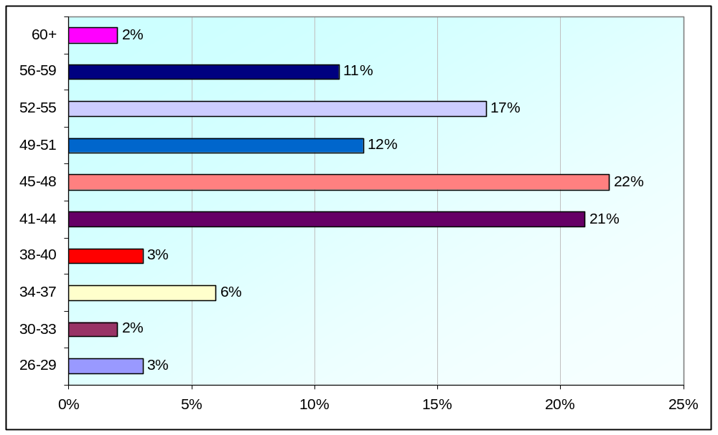

Figure 12. Age group of respondents (n = 270)

4.6.3 Ethnicity: The respondents were predominantly White-British (97%) with very few from other ethnic groups represented (see Table 35).

Table 35. Ethnicity data of respondents (n = 270)

Ethnic Group | % of Respondents
White-British | 95.6%
White-Irish | 1.5%
White-Other | 1.1%
White and Asian | 0.4%
Indian | 0.4%
Any other Asian | 0.4%
Chinese | 0.7%

4.7. INFORMATION RETRIEVED FROM TELEPHONE INTERVIEWS: Structured telephone interviews of a purposive sample of key stakeholders were undertaken (see Table 36):

Table 36. Key stakeholders interviewed

Key Stakeholders | N
Course leaders | 3
Medical prescribers (assessors) | 2
Prescribing leads | 3
Senior nurses/managers | 2
Pharmacists | 1

These professional groupings were chosen because they potentially have the most to say about the CPD needs of non-medical prescribers. They have contact with those who are in the process of or have completed their training. They provide support by allocating time to undertake the programme, mentoring and assessing, sharing of knowledge and experience, and provision of informal or formal CPD for post-qualifying staff. A pharmacist was included in the interviews because this professional group are now coming forward to train and even though the numbers are small, these are likely to grow following the changes from May 1st 2006 offering them opportunities to develop their role in prescribing (DH April 2006).The telephone interviews included closed and open-ended questions in order to elicit

information and views about present and future CPD provision for non-medical prescribers.

The data was examined using a qualitative analytical framework. Each interview question was considered separately and the response compared with those provided by the other respondents. This presented an opportunity to undertake a comparative analysis to explore the data for themes. This was used specifically for the data produced that did not ‘sit’ within the interview questions. For example when a respondent raised a matter related to non-medical prescribers that was outside the interview schedule.

4.8. FINDINGS
We have tried to maintain anonymity throughout by ensuring that individuals are not identifiable. Anonymity was further ensured by not identifying the areas of professional practice of each professional group. The findings for each professional grouping are presented separately and a discussion section examines the main themes that arose from the combined interviews.

4.8.1. Medical assessors
Both medical assessors were working with students undertaking the programme at the time of the interviews. Both received the relevant information packs relating to the students programme of study and reported that they found the information helpful. Neither had attended any of the Surrey and Sussex SHA study days or updates for non-medical prescribers. The following points were raised by both interviewees:

4.8.1.1. The importance of physical assessment skills: Highlighting in particular diagnostic skills; being able to make an appropriate diagnosis to prescribe. One interviewee emphasised the importance of the student, once qualified being able to complete physical assessments otherwise their prescribing ability would be greatly limited.

4.8.1.2. Working closely with the student: This was emphasised by both interviewees and the importance of on-going contact after qualifying.

4.8.1.3. Other comments:
1. The importance of national and local networks;
- Practising safely – the testing of competences in prescribing;
- Locally provided CPD to include testing understanding of the legal aspects of prescribing.

4.8.2. Programme leaders
None of the programme leaders possessed qualifications in non-medical prescribing. All were aware of CPD study days run by the Surrey and Sussex SHA. One has contributed to the study days through presenting a paper.

All sent out course details to the medical assessors who were assessing students on the next programme of study. All medical assessors were invited to join the programme leader or other responsible teacher at an introductory briefing session relating to their role and the students’ programme of study. All programme leaders identified concerns about the low level of attendance at the briefing day for medical assessors; one programme leader mentioned the different approaches they had used to raise the level of attendance including giving six months’ notice to evening meetings. One institute arranges personal visits to medical assessors who are unable to attend the briefing meetings. Most, if not all, medical assessors were contacted prior to commencing their role if they had not attended the introductory briefing.

All programme leaders highlighted the pending re-validation process which will be occurring either this year or next. The following curriculum issues were raised by one or more of the programme leaders:

4.8.2.1. Pharmacology input to the programme: For example, the subject area of anti-depressants - this area of pharmacology is relevant to more practitioners than mental health nurses.

4.8.2.2. The coverage of specialist areas: particularly pharmacology: finding the right teachers and ensuring that the subject is covered adequately.

4.8.2.3. Other comments:
1. The programme is not a pharmacology course but a prescribing programme – the need to cover how prescribing works and concordance was emphasised.
- The extra pressure of constant change and trying to keep the curriculum up-to-date.
- The inclusion of other professionals, including radio-graphers and pharmacists, on the programme and the importance of linking with other faculties in the universities that will have different perspectives on prescribing, particularly pharmacists.
4.8.2.4. Greatest achievements of non-medical prescribing programmes: The following points were made to this question:

- Enabling previously traditionally taught students to learn using open and independent learning.
- Achieving a level 6 (current HE level 3) qualification.
- Once qualified, staff being re-cognised for the prescribing skills they possess.
- Having a role where they are able to focus on prescribing.
- Having the attitude and skills to fulfil the role.
- As a teacher – it is an ‘eye opener’ working with other professional groups and other university schools (which may be outside their faculty). This was viewed as ‘healthy’ by one programme leader.
- Keeping up with the rapid and ongoing changes.
- Ensuring that the curriculum content is applicable to practice.

4.8.2.5. Greatest challenges for the future of the non-medical prescribing programmes: the following points were made:

- The under-funding for specific teaching areas such as medical law, ethics and pharmacology. Two programme leaders specifically highlighted the importance of the need to use appropriately qualified staff.
- The support and good will of external speakers was recognised. One programme leader stated that external speakers made a ‘big commitment’ to the programme.
- Providing adequate support in practice to students and medical assessors.
- Acknowledgement of the CPD needs of teaching staff linked with the programme. Staff may not always be up-to-date with the rapid changes in non-medical prescribing.
- The importance of Fiona Peniston-Bird’s visits to talk with students in the later stages of their programme.
- The influence of the Surrey and Sussex SHA in ensuring that everyone who is prescribing has achieved the same level of training (or having the same qualification where appropriate).
- There needs to be curriculum development at the pre-registration stage to ensure that on qualifying nurses are more prepared to cope with the demands of the non-medical prescribing programme.
- The inadequacy of the pharmacology input at pre-registration was emphasised. The need to bridge the gap between the two programmes was recognised.
- The lack of knowledge of chemistry, mathematics and pharmacology at the pre-registration stage became evident when students accessed the non-medical prescribing programme. One programme leader stated that this was being addressed at pre-registration level.

4.8.3. Clinical Managers
The managers interviewed did not hold a non-medical prescribers qualification or have any direct responsibilities for non-medical prescribing as facilitators or prescribing leads.

There was recognition of the course demands on students. One manager talked about the need of applicants to ‘do their home work’ before starting the programme including discussing the programme demands with someone who has completed the programme or shadowing someone who prescribes.

A question was posed by one of the managers – should ‘we’ be encouraging staff to complete a psychopharmacology course prior to commencing the non-medical prescribing programme (in relation to mental health nurses)?
Setting up support networks for mental health non-medical prescribers was viewed as embryonic in their development. Suggestions made included:
- Continuation of support from the medical assessors for at least six months to be followed on with specific clinical supervision sessions focussing on prescribing.
- To define roles and responsibilities – how will the non-medical prescribers work alongside other colleagues? What are the expectations of non-medical prescribers once they are qualified?
- Setting up joint support groups for medical staff and non-medical prescribers with a senior doctor facilitating who has experience of being a medical assessor.

The provision of a variety of ‘in-house’ courses to suit the different non-medical prescribers needs was viewed as challenging by one manager. It was suggested that education should be purchased after an initial needs assessment had been carried out.

4.8.4. Prescribing Leads
Two out of the three interviewees held non-medical prescribing qualifications. One firmly believed that staff embarking on the programme should already be in a role so they can prescribe on successfully completing the programme. In relation to the programme the following comments were made:

- That the Objective Structured Clinical Examination (OSCE) should be included as an assessment tool on the non-medical prescribers programme because of the way it assesses prescribing skills.
- It was thought by one prescribing lead that too much of the non-medical prescribers programme content was linked with primary health care. It was suggested that more teaching time be given to the legalities of prescribing, decision making and appropriate prescribing.

The following examples of support in practice were given:

- Prescribing facilitators were available to help with any difficulties students experienced in practice and after qualifying.
- Pharmacists were available to support and advise non-medical prescribers and can provide 1:1 sessions if necessary.
- Annual appraisals of non-medical prescribers were being developed.
- Bimonthly meetings are occurring in some parts of the Surrey and Sussex SHA organised by non-medical prescribers.
- Annual workshops which are case study based.

Prescribing leads were aware that some practice nurses attend CPD in their own time. Some attend short sessions which utilise an extended lunchtime period.

When asked to identify the CPD needs of non-medical prescribers the following points were raised:

- One interviewee stated that the individual non-medical prescriber has a responsibility for his/her own CPD updates as they are experts in their own field of practice.
- Non-medical prescribing con-ferences and study days provided by the Surrey and Sussex SHA may not meet individual needs and may not cover specialist practice areas.

When asked about the reasons given by non-medical prescribers for not attending CPD updates provided locally and by the Surrey and Sussex SHA, interviewees were aware of some staff having to attend in their own time as their managers may not allow CPD in work time. Furthermore, general practitioners may not recognise specific non-medical prescribers’ CPD.

The following suggestions on how Acute and Primary Care Trusts and universities could best provide CPD were made:

- Ring fenced time.
- Development of local models of CPD – kept local to address local issues and not necessarily provided by the universities.
- For Trust staff to be asked what do you need/want? However, it was suggested that some staff and Trust managers may not be aware of what they want in relation to CPD.

4.8.5. Pharmacist
The pharmacist described the support he offered to non-medical prescribers. He could be contacted by phone or email and emailed relevant information and articles to non-medical prescribers. He also provided teaching in the form of clinical updating. He was aware of the non-medical prescribing Surrey and Sussex SHA study days and had attended a conference.

The pharmacist confirmed many issues that had been described by the other interviewees from a different professional perspective. The points raised were:

- Training in advance of accessing the non-medical prescribing programme may be useful with a suggestion of a pre-requisite of studying pharmacology.
- The importance of having everything in place for staff once they have successfully completed the non-medical prescribers programme and being in a role where they can prescribe. He commented that non-medical prescribers must be up to it.
- The importance of being up-to-date with current evidence.
- The importance of listening to non-medical prescribers to find out their opinions.
- That Trusts need to state what it is they are expecting non-medical prescribers to do; expectations should be included in their contracts.
- It was not enough to view non-medical prescribers as being able to ‘cover’ doctors.
- Suggestion of a mandatory requirement to obtain regular support.

One of the main concerns of the pharmacist was the diagnostic skills of the non-medical prescribers, in particular screening unusual illnesses. It was stated that there was the potential for nurses and pharmacists to make an incorrect diagnosis - cancer and unusual illnesses were cited as examples.

The pharmacist was the only interviewee to raise the subject of contact with pharmaceutical companies and their representatives. The Association of the British Pharmaceutical Industry has a set of standards and the use of incentives to encourage doctors to prescribe is regulated, however, nurses are relatively inexperienced communicating with pharmaceutical companies in relation to prescribing. The pharmacist raised this issue stating the importance of remaining unbiased when prescribing. The pharmacist thought that nurses may not be as cynical as medical staff when dealing with these issues.

SUMMARY

5.1. What are the education and training gaps, deficits and limitations?
The university programmes for non-medical prescribers (NMPs) were considered appropriate and well organised and met the initial requirements for the education of NMPs

Pharmacology and prescribing is a rapidly moving discipline that requires regular CPD in order to keep up to date with the latest developments. Likewise, non-medical prescribing is a comparatively new innovation to the NHS, therefore those who are not medically qualified need mentorship from experienced prescribers, as well as the encouragement to be confident prescribers themselves.

- Short courses (one-day or two-day) that were specific to their role were generally considered to be the most popular and useful.

- Courses to be advertised well in advance (at least 6 weeks’ notice) in order that the NMPs were able to arrange workload and other commitments around the programme of choice. In addition, clarity by the education providers by providing the learning outcomes on the flyer would be helpful for NMPs to make choices regarding the usefulness of the short courses.

- Subject areas with respect to training gaps considered by the NMPs audited to be important were as follows:
  - Eczema and skin updates
  - Diabetes
  - Hypertension
  - Infections and antibiotics
  - Legal issues relating to prescribing
  - Prescribing update
  - Interpreting statistics in order to understand pharmaceutical company data
  - Basic pharmacology updates
  - Clinical skills training related to scope of practice for the respective NMPs

4. Whilst we do have confidence in our findings and the conclusions we have drawn from them, we also acknowledge that there are limitations with the data:

- The limited number of NMPs who took part in the training needs analysis.

- Incomplete data on needs analysis of all NMPs in the Surrey and Sussex SHA due to the low response rate. This was attributed to, at least in part, the dynamic nature of job changes within the region that meant so many had moved to new posts. Accordingly, this database was updated.

5.2. What CPD has been of use and for whom?
As acknowledged in section 1. The information provided should be viewed with a certain amount of caution and we would recommend that the Surrey and Sussex SHA issues regular bulletins and requests for NMPs update courses in order to ensure that it reflects the interests of those working in the area.

A significant way forward would be via the university programmes to request information on required CPD from students who work with other NMPs.

The professions of the NMPs included:
- District nurses,
- Community psychiatric nurse
- Child nurse specialists
- GP practice nurses
- Nurse consultants
- Health visitors
- Nurse practitioners

A further word of caution, since this training needs analysis was commissioned, is that there have been significant and recent changes in the scope of practice for NMPs and thus the professions that are accessing programmes of study and therefore able to prescribe, e.g. mental health nurses, substance misuse nurses and pharmacists.

We feel sure that information gathered from this training needs analysis, together with the evaluation of short courses and conferences that are offered and sponsored by the Surrey and Sussex SHA should provide a good insight into the needs of the NMPs in the area.

5.3. Areas for consideration
- The importance of clinical skills training linked to non-medical prescribing courses.
- Close contact with medical assessors after qualifying through support groups or individual networking.

- The significance of local support groups – in order to address local CPD issues at their meetings

- The importance of non-medical prescribers having the appropriate pharmacology knowledge. Should there be a pre-requisite for nurses wanting to enrol on the non-medical prescribers programme to attend a pharmacology module?

- Once qualified as non-medical prescriber, a clearly defined role which includes responsibilities for prescribing.

REFERENCES

Department of Health (2006) Improving patients’ access to medicines: A guide to implementing nurse and pharmacist independent prescribing within the NHS in England. Department of Health. London

Latter, S., Maben, J., Myall, M., Courtney, M., Young, A. and Dunn, N. (2004) An evaluation of extended formulary independent nurse prescribing. Final report. Department of Health and the School of Nursing and Midwifery, University of Southampton. Southampton.

Medicines and Healthcare Products Regulatory Agency, Department of Health (2005) Consultation on options for the future of independent prescribing by extended formulary nurse prescribers. Department of Health. London.

APPENDIX 1: ADDITIONAL DATA

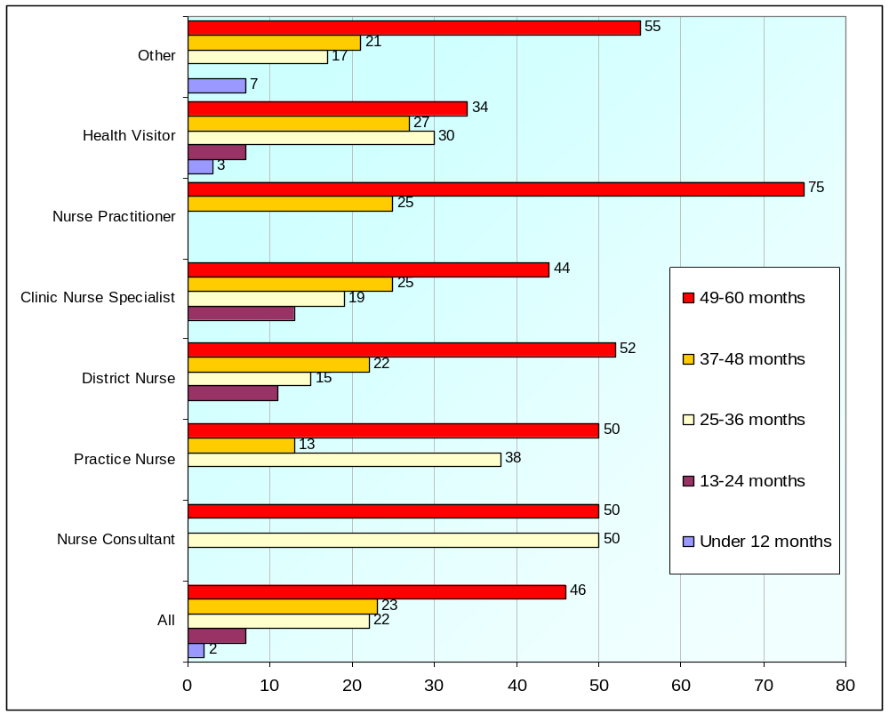
Figure A1: Nurse Prescriber (District Nurse or Health Visitor NMC V100)- Current job title and time taken to qualify – by current job title (n = 195)


11
0
0
0
14
8
25
33
19
50
0
20
14
25
0
33
44
50
67
40
57
33
50
33
14
0
0
0
14
25
25
0
11
0
33
40
0
8
0
0
0
10
20
30
40
50
60
70
80
all
Nurse Consultant
Practice Nurse
District Nurse
Clinic Nurse Specialist
Nurse Practitioner
Health Visitor
Other
49-60 months
37-48 months
25-36 months
13-24 months
Under 12
months

Figure A2: Extended Formulary Plus Supplementary Prescriber (NMC V200)- Time taken to qualify - by current job title (n = 36)


42
50
40
50
75
50
36
50
37
25
40
50
25
31
43
50
15
0
0
0
0
19
21
0
0
10
20
30
40
50
60
70
80
All
Nurse Consultant
Practice Nurse
District Nurse
Community
Psychiatric Nurse
Clinic Nurse
Specialist
Nurse Practitioner
Health Visitor
37-48 months
25-36 months
13-24 months
Under 12
months

Figure A3: Extended Formulary Plus Supplementary Prescriber (NMC V300):
Time taken to qualify - by current job title (n = 59)


33
1
0
0
67
14
1
40
0
1
0
33
57
0
13
0
0
0
0
29
0
0
20
40
60
80
All
Pharmacist
Nurse Consultant
Practice Nurse
Clinic Nurse
Specialist
Nurse Practitioner
Other
49-60 months
37-48 months
25-36 months
13-24 months
Under 12 months

Figure A4: Supplementary Prescribers (Pharmacist or other health professionals). Time taken to qualify - by current job title (n =15)

APPENDIX 2: QUESTIONNAIRE

Survey of Continuing Professional Development Needs of
Non-Medical Prescribers

Centre for Research in Nursing and Midwifery Education (CRNME)

European Institute of Health and Medical Sciences, University of Surrey

A. PROFESSIONAL DETAILS

1. What is your current job title? (Please tick one box only)

Pharmacist Community Psychiatric Nurse
Nurse Consultant Clinical Nurse Specialist
Practice Nurse Nurse Practitioner
District Nurse Health Visitor
Other – (Please tick box & specify) ____________________________________

- How long have you been practising in your present professional role?
(Please tick one box only)

Less than 2 years 2-5yrs 6-9yrs 10-13yrs 14-17yrs
18-21yrs more than 21yrs

3. Which of the following qualifications do you hold?

a) Professional and academic qualifications (Please tick all that apply)

RGN Certificate
RMN Diploma
DipHE RN (M) Degree
DipHE RN (Adult) Masters
DN Post-grad Diploma
HV PhD
BPharm MPharm
Other – (Please tick box & specify) ____________________________

b) Post-qualifying professional qualifications (Please tick all that apply)

Mentor qualification
Extended Formulary Nurse Prescriber (NMC V200)
Extended Formulary plus Supplementary Nurse (NMC V300)
Supplementary Prescriber (inc. pharmacists)
Nurse Prescriber - DN and HV (NMC V100)
Teaching qualification

4. In which of the following are you qualified and where did you study? (Please tick all that apply)

4a Nurse prescriber (District Nurse or Health Visitor (NMC V100)
under 12months 13-24months 25-36months
37-48months 49-60months
At Brighton At Surrey Other (Please tick & specify)________________

4b Extended formulary nurse prescriber (NMCV 200):
under 12months 13-24months 25-36months
37-48months 49-60months
At Brighton At Surrey Other (Please tick & specify)________________

4c Extended formulary plus supplementary prescriber (NMC V 300):

under 12months 13-24months 25-36months
37-48months 49-60months
At Brighton At Surrey Other (Please tick & specify)________________

4d Supplementary prescriber (pharmacist, or other health professional,
e.g. SP ‘as top up’ )
under 12months 13-24months 25-36months
37-48months 49-60months Other
At Brighton At Surrey Please tick & specify)________________

4e. Did you consider that the content of the course of study (as above) provided an appropriate knowledge base for you to fulfil your role in prescribing
Yes No (if ‘NO’ explain your reasons)

5. Are you studying for a further academic qualification?

Yes No (if ‘NO’ go to Section B)

5a. What academic level are you studying towards (Please tick one box only)

Certificate Degree
Diploma Masters
Post-grad Diploma PhD
Professional doctorate

Other – (Please tick box and specify) ______________________________________________________

5b. Please indicate which subject area represents your major area of study
(Please tick one box only)

Specialist area of practice Generic HV Mentorship
Pharmacy/pharmacology Generic nursing Nurse prescribing
Social sciences Psychology Biological sciences
Counselling/psychotherapy Teaching
Other – (Please tick box & specify) _______________________

B PRACTICE EXPERIENCE DETAILS

1a. Please state specialist area of present practice that best captures your practice area
(Please tick all that apply)

Mental health: community Mental health acute care
Mental health drug and alcohol misuse Mental health continuing care
Mental health rehabilitation Mental health older people
Elderly care: acute admission Elderly care continuing care
Elderly care: rehabilitation Palliative care

Coronary care Health visiting District nurse
Pharmacy – community Pharmacy - hospital Pharmacy - mental health

Diabetic clinic General practice primary care
Accident and Emergency Women’s health
Contraception and sexual health Other – (Please tick box & specify) ________________

1b. How long have you been practicing in this area? (Please tick one box only)

under 12months 13-24months 25-36months
37-48months 49 -60months >60 months

If less than 12 months, please answer questions 1c below otherwise GO TO Question 1d

1c. If you have been in your present post for less than 1 year, please tick the area of work that best represents your previous area of practice

Mental health: community Mental health acute care
Mental health drug and alcohol misuse Mental health continuing care
Mental health rehabilitation Mental health older people
Elderly care: acute admission Elderly care continuing care
Elderly care: rehabilitation Palliative care

Coronary care Health visiting District nurse
Pharmacy – community Pharmacy - hospital Pharmacy - mental health

Diabetic clinic General practice primary care
Accident and Emergency Women’s health
Contraception and sexual health Other (Please tick box & specify) ________________

1d). Are you employed (Please tick one box only)

Full-time Part-time (not job share) Job share

1e) If part-time or job share how many days do you work per week in this job?
(Please tick one box only)

0-4 hrs 5-8hrs 9-12hrs 13-16hrs 17-20hrs
21-24hrs 25-28hr 29-32hrs 33-36hrs
more than 36 hours

(If >36 hours /week, please provide hours worked) ____________________________________________

1f) What is your current grade? (Nurses and midwives grades):

‘D’ ‘E’ ‘F’ ‘G’
‘H’ ‘I’ Other: Do not know:

OR What is your current pay scale on the Agenda for Change

‘4’ ‘5’ ‘6’ ‘7’
‘8a’ ‘8b’ ‘8c’ Other:

PHARMACISTS ONLY:
1g) What qualification do you hold to practice?

MPharm. BPharm. Other:

1h) What is your current role?

Pharmacist Assistant Pharmacist Other:

1j) If working as a hospital pharmacist, please state grade/title

___________________________________________________________________________________

1m) Is your employer (Please tick one box only)

NHS Agency Private health sector Social services
Independent/freelance (self-employed) Voluntary sector

1n) Health/social care provision:

Private NHS Social services

2. In a typical shift or span of duty, how often to do you prescribe when working in your practice area? (Please tick one box only)

Once during a working shift or span of duty
2-4 times during a working week
Once during a working week
Fortnightly
Monthly
Less than once a month
Not prescribed since completing my
non-medical prescribing programme
Not applicable

3. How often do you implement a Clinical Management Plan with an independent medical prescriber? (Please tick one box only)
Once during a working shift 2-4 times during a working week
Once during a working week Fortnightly
Monthly Less than once a month
Not applicable

4a.How would you describe your self as a prescriber? (Please tick one box only)
Extremely confident Fairly Confident
Neither confident nor unconfident Fairly unconfident
Extremely unconfident

4b. Please say why you gave the answer above:

___________________________________________________________________________________

5a. How far do you agree or disagree with the following question?

‘The role of a prescriber enhances my professional role’( Please tick one box only)
Strongly agree Agree Neither agree nor disagree Disagree Strongly disagree

5b. Please say why you gave the answer above:

__________________________________________________________________________________

C. CONTINUING PROFESSIONAL DEVELOPMENT

1) Have you completed any courses or programmes of study provided by your employer within the last 12 months?
- Specific to your clinical specialty Yes No Days: ½ 1 2 3 4 5
- Mandatory study days (for example CPR) Yes No Days: ½ 1 2 3 4 5
- Specific to your role as non-medical prescriber Yes No Days: ½ 1 2 3 4 5
- Conferences on non-medical prescribing Yes No Days: ½ 1 2 3 4 5

2) Have you completed any courses or programmes of study provided by an organisation other than your employer within the last 12 months?
- Specific to your clinical specialty Yes No Days: ½ 1 2 3 4 5
- Mandatory study days (for example CPR) Yes No Days: ½ 1 2 3 4 5
- Specific to your role as non-medical prescriber Yes No Days: ½ 1 2 3 4 5
- Conferences on non-medical prescribing Yes No Days: ½ 1 2 3 4 5

3a) If you have attended a national conference on prescribing in the last 12 months how far do you agree with the following statement (If more than one attended please answer in relation to the most recent one) ‘I was able to apply what I learned at the conference to my practice’

( Please tick one box only)

Strongly agree Agree
Neither agree nor disagree Disagree
Strongly disagree

3b) Please say why you gave the above response

3c) Name of Conference:

___________________________________________________________________________________

4a. If you have attended a Surrey and Sussex Strategic Health Authority Conference within the last 12months on prescribing how far do you agree with the following statement?

‘I was able to apply what I learnt to my practice’ ( Please tick one box only)

Strongly agree Agree
Neither agree nor disagree Disagree
Strongly disagree

4b) Please say why you gave the above response

___________________________________________________________________________________

4c) Name of Conference:

___________________________________________________________________________________

4d) Have you attended a course or programme specific to prescribing within the last 12 months?

Yes No

If Yes, Please state name of course/programme _____________________________________________

4e) Thinking about this course or programme of study how far do you agree with the following statement: ‘I was able to apply what I learnt to my practice’ ( Please tick one box only)

Strongly agree Agree
Neither agree nor disagree Disagree
Strongly disagree

4f) Please say why you gave the above response

___________________________________________________________________________________

4g) Please give the name of the conference:

___________________________________________________________________________________

4h) If you have not attended any conferences, courses or programmes in the last 12 months when was the last time you attended study relating to your prescribing role post-qualifying.
(Please tick one box only)

13-18 months ago 19-24 months ago
25-30 months ago 31-37 months ago
More than 37 months ago Have Never attended

5. Which of the following has been your main source of information about prescribing?
(Please tick ALL that apply)

Training days (local) Local trust prescribing group
Training days (national) Circulated information
Journals Other literature (e.g. drug companies)
Websites Colleagues
Manager Other (Please tick box and specify) _____

6. Please rank your prescribing continuing professional development needs in order of importance
1 – most important 10 – least important

Principles of Pharmacology 1 2 3 4 5 6 7 8 9 10

Drug administration 1 2 3 4 5 6 7 8 9 10

Patient/client assessment 1 2 3 4 5 6 7 8 9 10

Non-medical prescribing information 1 2 3 4 5 6 7 8 9 10

Physiology 1 2 3 4 5 6 7 8 9 10

Psychopharmacology 1 2 3 4 5 6 7 8 9 10

Biological sciences 1 2 3 4 5 6 7 8 9 10

Decision making skills 1 2 3 4 5 6 7 8 9 10

Drug/pharmacology law 1 2 3 4 5 6 7 8 9 10

Support from experienced prescribers 1 2 3 4 5 6 7 8 9 10

Other (name and add rank number) 1 2 3 4 5 6 7 8 9 10

Please specify _____________________________________________________________________

7. How would you prefer to gain your continuing professional experience?
Please rank in order of preference
1 – most preferred 10 – least preferred

Distance learning 1 2 3 4 5 6 7 8 9 10

E learning 1 2 3 4 5 6 7 8 9 10

Lectures 1 2 3 4 5 6 7 8 9 10

Conferences 1 2 3 4 5 6 7 8 9 10

In the practice setting with colleagues 1 2 3 4 5 6 7 8 9 10

Short courses 1 2 3 4 5 6 7 8 9 10

Training days 1 2 3 4 5 6 7 8 9 10

Self-directed learning 1 2 3 4 5 6 7 8 9 10

Other (name and add rank number) 1 2 3 4 5 6 7 8 9 10

Please specify _____________________________________________________________________

8. Are there any other comments that you would make to like regarding the continuing professional development needs of non-medical prescribers? (Please write in box below)

C DEMOGRAPHIC INFORMATION

1. Are you: ?
Male Female

2. How old are you?
i) 18-21 ii) 22-25 iii) 26-29 iv) 30-33
v) 34-37 vi) 41-44 vii) 45-48 viii) 49-51
ix) 52-55 x) 56-59 xi) 60 or over

3. Do you have any form of physical or learning disability? (Please tick one box only)
Yes No

4. Which of the following best describes your ethnic origin? (Please tick one box only)
a I am White:
⁪ White – British
⁪ White – Irish
⁪ White – Other – Please specify ___________________________________
b I am of Mixed Background:
⁪ White and Black Caribbean
⁪ White and Black African
⁪ White and Asian
⁪ Any other mixed background – Please specify _______________________

c I am Asian, Asian British, Asian English, Asian Scottish or Asian Welsh.
⁪ Indian
⁪ Pakistani
⁪ Bangladeshi
⁪ Any other Asian background – Please specify ________________________
d I am Black, Black British, Black English, Black Scottish or Black Welsh.
⁪ Caribbean
⁪ African
⁪ Other Black background – Please specify ____________________________
e I am Chinese, Chinese British, Chinese English, Chinese Scottish, Chinese Welsh or other ethnic group.
⁪ Chinese
⁪ Any other background – Please specify ______________________________

My Nationality is: ____________________________________________________
(according to passport)

THANK YOU FOR COMPLETING THIS QUESTIONNAIRE
Please return in the FREEPOST envelope

