Student Information Meningitis ACWY
As of August 2015 all first-time university students up to the age of 25 (and 17- and 18-year-olds in school year 13) and are eligible for the Men ACWY vaccine as part of the NHS vaccination programme.
The Men ACWY vaccine protects against four different causes of meningitis and septicaemia – meningococcal (Men) A, C, W and Y diseases. The vaccine provides good protection against serious infections caused by four different meningococcal groups (A, C, W and Y) including meningitis and septicaemia.
Cases of meningitis and septicaemia (blood poisoning) caused by Men W bacteria are rising due to a particularly deadly strain. Older teenagers and university students are at high risk of infection because they tend to live in close contact in shared accommodation, such as university halls of residence. The meningococcal bacteria live in the back of the nose and throat in about 1 in 10 of the population without causing any illness. The bacteria is spread from person to person by close prolonged contact with a person carrying the bacteria, such as coughing, kissing and sneezing.
First time students under 25 can access the vaccine from their home GP or by registering with Guildowns University Medical Centre via Campus Doctor and then booking an appointment at the Doctor’s practice.
Symptoms of meningitis are
•a fever, with cold hands and feet
•vomiting
•drowsiness and difficulty waking up
•confusion and irritability
•severe muscle pain
•pale, blotchy skin, and a distinctive rash (although not everyone will have this)
•a severe headache
•stiff neck
•sensitivity to light (photophobia)
•convulsion or seizures
These symptoms can appear in any order, and not everyone will get all of them. Don't wait for a rash to develop. If someone is unwell and has symptoms of meningitis, seek medical help immediately.
To test for a non-blanching rash (one which does not fade under pressure) press an empty glass against the affected area.

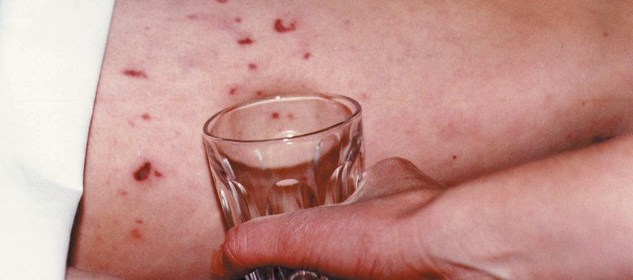
Check symptoms now

If you are concerned about your health or the health of your friends, call security on 2002 and let them know that you suspect meningitis. Alternatively, call 111 or 999 and explain the symptoms, they will arrange an appropriate medical response.

