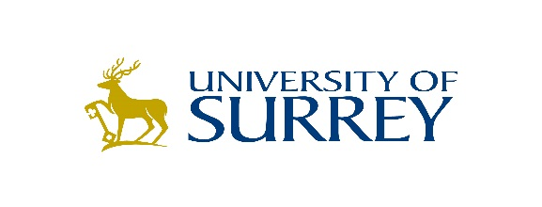
Santander Universities
Researcher Mobility (Outgoing) Awards 2018/19
Application Form

These awards provide grants of up to £2000 for full-time PhD students and staff at the University of Surrey to spend up to six months conducting research at a university overseas listed as a member of the Santander Universities Network. For further details on eligible destinations, please visit the Santander website.

Applicant details
Name:

University/staff number (URN): |  | Department / Faculty:

Telephone number: |  | Email address:
PhD start and end dates/employment start date: |  | Field of research:

Research at Partner University
Partner University:
Destination country:
Please give a title that reflects the focus of the research during the time spent overseas:

Supervisors
Supervisor/Line Manager at Surrey:

Proposed start and end dates of research visit
Start date: |  | End date:

Brief project description
Please give a description of up to 1 page (font 11, single-spaced) of the project. Please include:
- a brief description of the research area
- a summary of the activities to be undertaken during the visit
- expected results from the period of research at the partner university
- how the visit supports the aims and objectives of the University’s Global Strategy

Budget
Please give a breakdown of the budget, up to a maximum of £2000

Item | Cost | Comments
Return flight/travel expenses
Visa costs
Travel to and from airport
Subsistence
Accommodation
Other costs (please specify)

Short CV
Maximum one page for the applicant

Supporting statements
Please provide short supporting statements (c.200 words) from the supervisors/line managers. These can be written directly into the application forms by the supervisors, or cut and paste from an e-mail.

Please email the completed application form to Louise Lawton in the Global Engagement Office (louise.lawton@surrey.ac.uk)

Terms and conditions:

- Successful applicants will be expected to write a report of their visit within one month of returning to the UK. The report will be shared with Santander and may feature in online and printed marketing and promotional pieces.
- All successful applicants must complete their visit overseas by 31st December 2019.
- Successful applicants are expected to attend future Santander functions to promote the benefits of the scheme.
- If a student/staff member is selected to receive an award, but does not undertake their visit, they will not receive any funding and the award cannot be taken in the following year.

