Guidelines to format one-page abstracts for IASS2020-Surrey 7th
Corresponding AUTHOR*, Forename B. SURNAMEª, Another AUTHOR^{b}
*Affiliation of Corresponding Author
Address of Corresponding Author
Email Address of Corresponding Author

ª Affiliation of another author if different from Corresponding Author
^{b} Affiliation of another author if different from other authors

Abstract
This document contains information about the required format of abstracts for peer review. Abstracts must be written in English and should be laid out on A4 paper size. You can produce your abstract by simply replacing the contents of this file and saving it as a PDF document (.pdf file format). Your abstract should be one page maximum and may include text along with equations, figures, and references as appropriate. Please use the Times New Roman 11pt font supplied in this template (Style: Normal). If you do include references, be sure to use the IEEE citation style. Please remember that your submitted .pdf files should not be password protected or otherwise locked.
The title of the paper should be explicit, descriptive and as brief as possible – no more than 20 words in length and in 16pt bold, which should have capital letters only at the beginning of the first word and for proper nouns or acronyms. The names of all authors are in 11pt as well as the affiliation of all authors. Note that the corresponding author should be marked with an asterisk. Please also use all caps for the surnames of all authors and precede the surname by the full forename (not just initials). The abstract is preceded by the 12pt bold word “Abstract”, while the text is 11pt fully justified. Any equations or formulae should be centered.
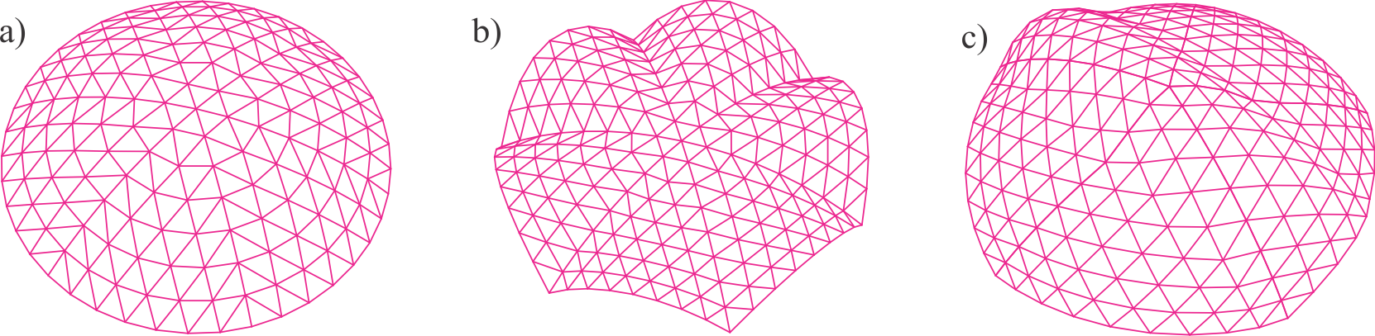
Figure 1. Examples of forms of lattice spatial structures, see Nooshin et al. [3], a) diamatic dome, b) scallop dome, c) freeform
If your abstract is accepted, you will be invited to submit a full paper. To improve the likelihood of your abstract being accepted, it is strongly recommended that it concisely includes: a clear description of the problem addressed by the research; a contextualisation of relevant previous work and how the present contribution is unique; a description of the methodology or approach used; and a discussion about the meaning, value, and impact of the results. Careful editing for clarity is also highly recommended. Note that the abstract must be submitted online via Easychair by February 15 2020.
Keywords: Include a list in 10pt Times New Roman [Style: Keywords] of fewer than ten keywords or terms, separated by commas, using nouns or adjective(s)-plus-noun forms that are relatively standard in the field of spatial structures. The keywords will be used by the scientific committee to manage and classify all the papers. (For example: conceptual design, morphology, form finding, optimization, concrete shells, metal spatial structures, membrane structures, earthquake design etc.)

References
- F. Fu and G. A. R. Parke, “Assessment of the Progressive Collapse Resistance of Double-Layer Grid Space Structures Using Implicit and Explicit Methods”, International Journal of Steel, vol. 18, pp. 831-842, 2019.
- S. Adriaenssens, P. Block, D. Veenendaal and C. Williams (eds.), Shell Structures for Architecture: Form Finding and Optimization, Routledge, 2014.
- H. Nooshin and O. A. Samavati, “Some Morphological Aspects of Configurations ,” in Spatial Structures in the 21st Century: Proceedings of the IASS Annual Symposium 2016, Tokyo, Japan, September 26-30, 2016, K. Kawaguchi, M. Ohsaki and T. Takeuchi, Eds.

