Title of Contribution

[All submissions must not include information identifying the authors or their affiliations – author details to be added ONLY after acceptance/final version]
FirstName1 LastName1
Position
School of XX, University of XX, Country
Email: address@university.edu

FirstName2 LastName2
Position
School of XX, University of XX, Country
Email: address@university.edu

FirstName3 LastName3
Position
School of XX, University of XX, Country
Email: address@university.edu

Keywords: research; tourism management; human flourishing [include at least 3 keywords]

Abstract

The word limit for extended abstract submission to the Surrey 2023 Conference is 500 words, excluding references, tables, and figures/illustrations. This should include your research background, aims and objectives, theoretical framework, methods, findings, and conclusion. Please find below some tips on how to write your abstract.

Comply. Diligently follow all abstract style and formatting guidelines. Most CFPs will specify page or word length, and perhaps some layout or style guidelines. Make sure that you strictly adhere to all guidelines, including submission instructions. If a CFP does not provide abstract style and formatting guidelines, it is generally appropriate to stay around 500 words – abstract committees read a lot of these things and do not look fondly on comparatively long abstracts. Make sure that you orient your abstract topic to address any specific CFP themes, time periods, and methods.

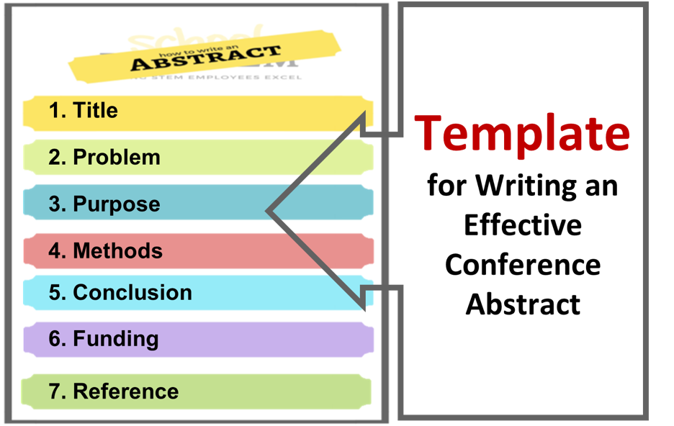

Figure 1. How to write a conference abstract

(https://fadic.net/courses/how-to-write-a-conference-abstract/)

Be Concise. With a 500-word limit, write only what is necessary, avoiding wordiness. Use active voice and pay attention to excessive prepositional phrasing.

Be Clear. Plan your abstract carefully before writing it. A good abstract will address the following questions: What is the historical question or problem? Contextualize your topic. What is your thesis/argument? It should be original. What is your evidence? State forthrightly that you are using primary source material. How does your paper fit into the historiography? What's going on in the field of study and how does your paper contribute to it? Why does it matter? We know the topic is important to you, why should it be important to the abstract selection committee?
You should be as specific as possible, avoiding overly broad or overreaching statements and claims. And that’s it: don’t get side-tracked by writing too much narrative or over explaining. Say what you need to say and nothing more. Keep your audience in mind. How much background you give on a topic will depend on the conference. Is the conference a general humanities conference, a general graduate student history conference, or something more specific like a 1960s social revolutions conference? Your pitch should be suited to the specificity of the conference: the more specific the topic, the less broad background you need to give and vice versa.

Be Clean. Revise and edit your abstract to ensure that its final presentation is error free. The editing phase is also the best time to see your abstract as a whole and chip away at unnecessary words or phrases. The final draft should be linear and clear, and it should read smoothly. If you are tripping over something while reading, the abstract selection committee will as well. Ask another graduate student to read your abstract to ensure its clarity. Your language should be professional, and your style should adhere to academic standards. Contractions may be appealing because of the word limits, but they should be avoided.

References
N/A (n/d). Tips for Writing Conference Paper Abstracts. https://history.ncsu.edu/grad/conference_abstracts.php

