How to upload datasets/code/models to Surrey University’s Repository (Esploro)

Before uploading

1. Ensure your files are well-organised, clearly and meaningfully named.
2. Prepare any associated documentation files that are needed to open, understand and re-use your data (code or model) files.
3. Create a [README file](https://data.research.cornell.edu/content/readme) for your files. You can use [this template](https://cornell.app.box.com/v/ReadmeTemplate). Save it as a plain text file.
4. Each *type* of file (data, code or model) should be uploaded into a separate metadata asset record.
5. For versioning purposes, you may upload an initial file release (e.g. Version 1) generated during your research programme, and subsequently add a final file release once your project is complete, to the same asset record.
6. Most importantly, please connect to and register your **ORCiD id** (watch video here: [Researcher Profiles (sharepoint.com)](https://surreyac.sharepoint.com/sites/LibraryResearchHub/SitePages/Researcher-Profiles.aspx)

Uploading data and setting access controls

1. [Sign into](https://openresearch.surrey.ac.uk/esploro/login?institution=44SUR_INST) Surrey’s Open Research repository using your username (e.g. ss0000) and password.

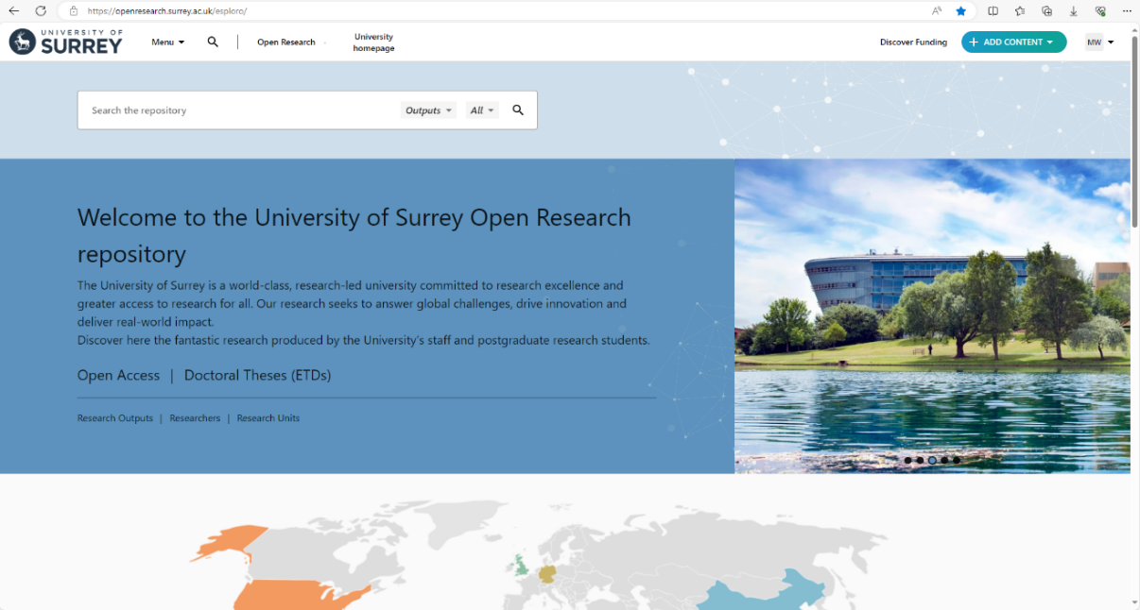

1. Click the “**+ ADD CONTENT**” button (top right) and select “**Output**”.
2. You can save your draft at any time by clicking the “**X**” on the top left and clicking “**Save draft**”. To continue editing, navigate to your “**Profile**”, click “**Outputs**”, and select the draft you want to work on.
3. THE ESSENTIALS Tab: **“What are you submitting?”**
4. Click “**Select asset type**”.  Select “**dataset**” (or “**code**” or “**model**”) from the list (or start to type it and select it).
5. **“Search for your dataset”**
6. If you’re sharing your data for the first time, skip this field.
7. Already have a DOI for your data? Enter your DOI in the “Search for your dataset” field. The system will attempt to import relevant information from where your dataset is published, provided that the DOI is active.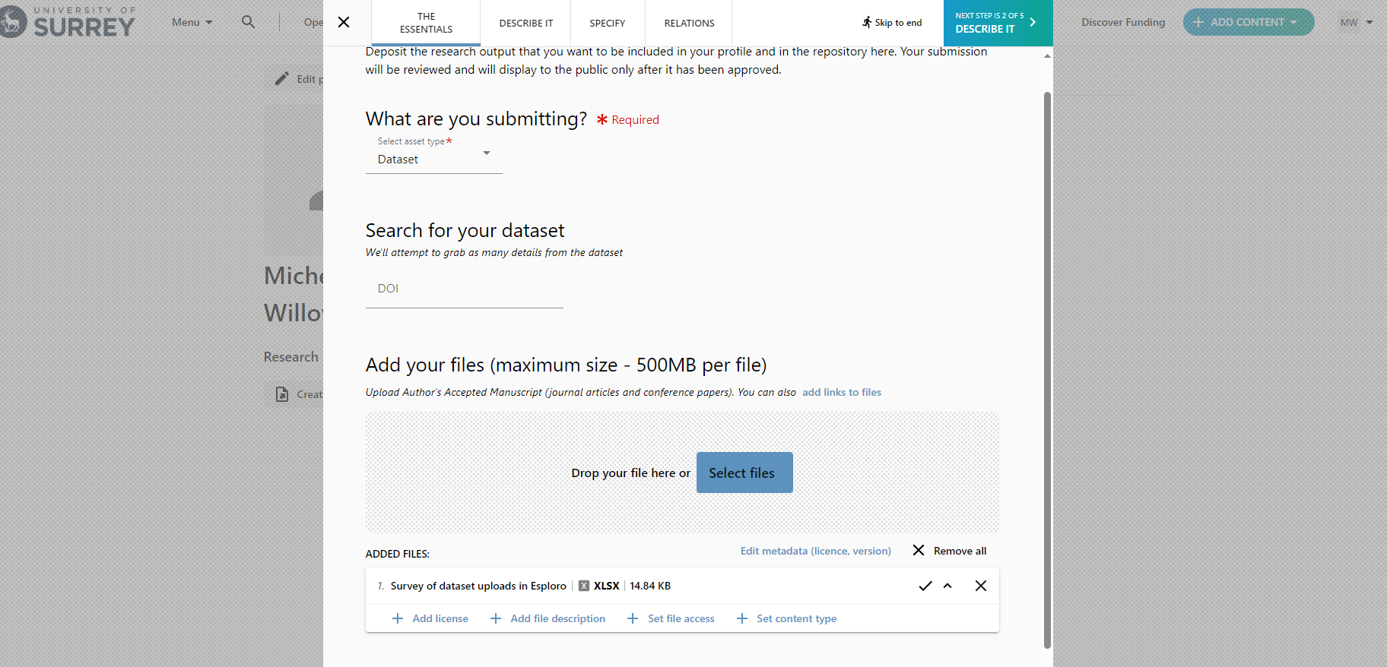
8. **“Add your files”**
9. If your data is already published elsewhere in an external disciplinary repository, just add a **link** to it by clicking on ”**add links to files**”.
10. Similarly, if your total file size is large (>200 MB), files will be permanently available and are not subject to change (e.g. are archived in an external repository), then just add a **link** to them by clicking on ”**add links to files**”.
11. Otherwise, to upload small sized files (<200 MB in total) drag and drop, or select multiple files to upload (Winzip can be used if folder structure hierarchy needs to be retained).
12. **CLICK** on each uploaded file to reveal several options. You should:
13. “**Add license**”: applies a [copyright license](https://www.surrey.ac.uk/library/open-research/copyright-and-licences) (e.g. CC BY V4.0). Click the relevant license to apply it *ONLY to that particular uploaded file*.
14. “**Add file description**”: adds a free text description of the particular file e.g. Version 1.0, Variable Definitions, Temperature Data, etc.
15. “**Set file access**”:  applies access rights to your particular uploaded file. Options include:

* **Everyone**: publicly accessible, everyone can download the file, (i.e. Open)
* **Everyone, limited by date**: restricts access to the file until a specific date, (i.e. Embargoed)
* **On request**: restricts access but allows someone to request access to the file, as long as your contact details (e.g. your email address at the end of your Abstract) are provided (i.e. Restricted)
* **No one (private)**: the file is not available (i.e. Closed)
* **Please note:** any restrictions on files should be accompanied by a justification. This could be at the file level (this step), within the dataset record’s description (next step), or in the README file.

iv. “**Set content type**”: file type e.g. external data location of landing web page, dataset, readme file, text file, guide, python script, CAD, etc.

1. Click on the DESCRIBE IT Tab along the top to proceed to next step.

Describe your data

1. **“Enter a title”**
2. Your title should be descriptive, concise and begin with “Data for…”, “Code for…”, or “Model for…”. Remember this is a research publication with its own DOI, which can be cited just like a journal article.
3. **“Research topics”**
4. Add relevant keywords/topics and **Sustainability Goals** or **SDG**s (*each phrase* *separated by pressing Return*) to help find/harvest your data/code/model and increase your citations. Further information on SDG’s is given at [SDG Research Publications](https://surreyac.sharepoint.com/sites/LibraryResearchHub/SitePages/Research-and-the-SDGs.aspx).

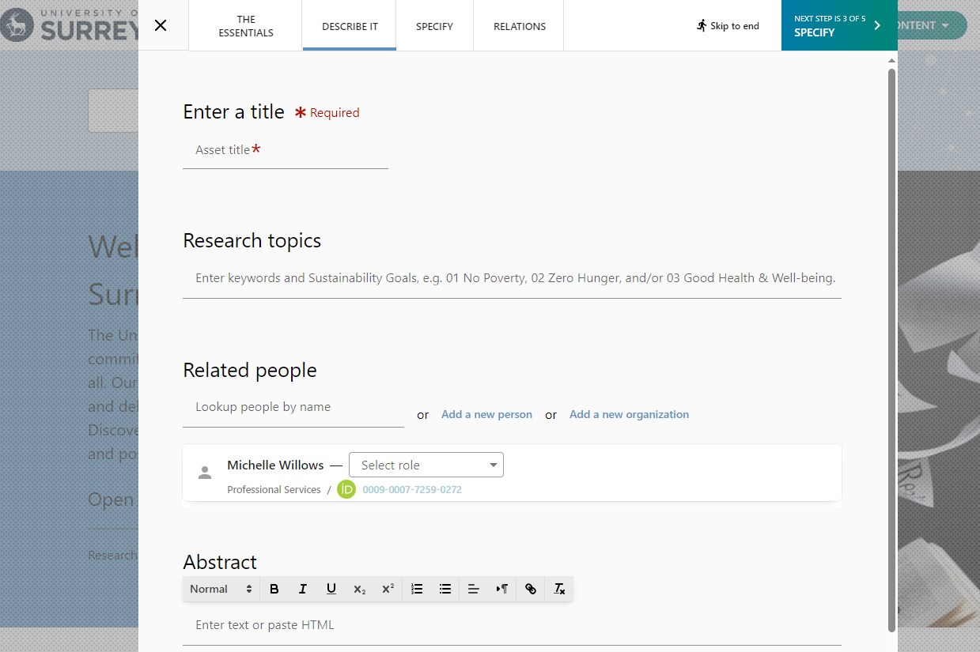

1. **“Related people”**
2. Start typing a name to see suggestions.  *Note that their unique* ***ORCiD id*** *appears here.*
3. If the name you’re looking for doesn’t appear, then click “**Add new person**”. You can add their name and affiliation. Similarly, you can “**Add a new organization**”.

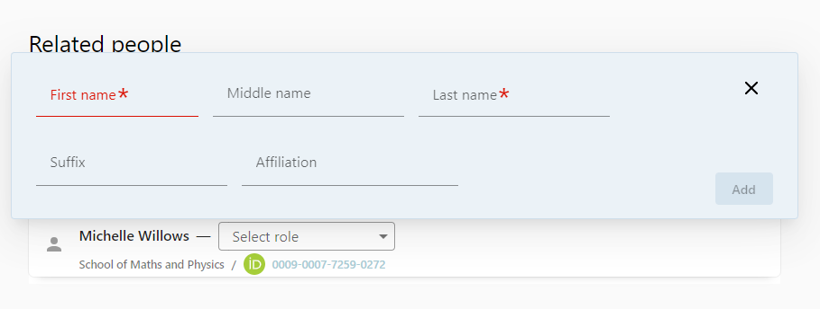

1. Next to each name you can “**select role**” to indicate their contribution/relationship to the dataset/code/model (Choose the DATA CURATION role from the CRediT Taxonomy standard).

|  |  |
| --- | --- |
| **CRediT role** | **Definition** |
| Conceptualization | Ideas; formulation or evolution of overarching research goals and aims |
| Methodology | Development or design of methodology; creation of models |
| Software | Programming, software development; designing computer programs; implementation of the computer code and supporting algorithms; testing of existing code components |
| Validation | Verification, whether as a part of the activity or separate, of the overall replication/ reproducibility of results/experiments and other research outputs |
| Formal analysis | Application of statistical, mathematical, computational, or other formal techniques to analyse or synthesize study data |
| Investigation | Conducting a research and investigation process, specifically performing the experiments, or data/evidence collection |
| Resources | Provision of study materials, reagents, materials, patients, laboratory samples, animals, instrumentation, computing resources, or other analysis tools |
| Data Curation | Management activities to annotate (produce metadata), scrub data and maintain research data (including software code, where it is necessary for interpreting the data itself) for initial use and later reuse |
| Writing – Original Draft | Preparation, creation and/or presentation of the published work, specifically writing the initial draft (including substantive translation) |
| Writing – Review & Editing | Preparation, creation and/or presentation of the published work by those from the original research group, specifically critical review, commentary, or revision – including pre-or post-publication stages |
| Visualization | Preparation, creation and/or presentation of the published work, specifically visualization/ data presentation |
| Supervision | Oversight and leadership responsibility for the research activity planning and execution, including mentorship external to the core team |
| Project administration | Management and coordination responsibility for the research activity planning and execution |
| Funding acquisition | Acquisition of the financial support for the project leading to this publication |

1. **“Description”**
2. This is the ***Abstract*** describing your data/code/model. The description will be prominently displayed under your title and rank highly in search results. It should help someone understand your data, the context in which it was collected, measured, generated, any formats used, hardware/software needed and any other relevant information. The better described your data, the more discoverable and reusable it will be.
3. If any of your files are restricted this is where you can outline why and under what conditions access will be granted (if any).
4. If your README file contains more details about your data and access restrictions, you can direct people to view that file in the description.
5. Click on the SPECIFY Tab along the top to proceed to the next step.

DOI and further description

1. **“Where was the data stored?”**
2. If you’re uploading your data/code/model to our repository, then enter “University of Surrey”.
3. If you have deposited your data externally, e.g. in another repository elsewhere (e.g. Figshare,  Zenodo, Github, UK Data Service, OSF, etc.) then list that repository.

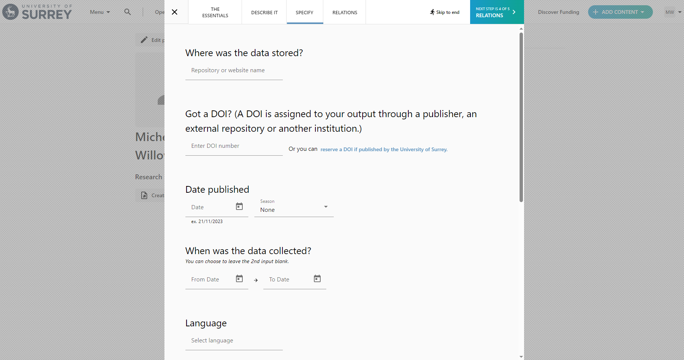

1. **“Got a DOI?”**
2. If your data/code/model has already been assigned a DOI, then enter it here, *as it should only ever have one DOI.*
3. If your data/code/model does not have a DOI, then click “**reserve a DOI**”.
4. Your reserved DOI will be displayed.
5. **Please note**: your DOI will **NOT** work (i.e. be found in searches) until the metadata asset record is *Approved*. Publication to the repository only occurs after the Open Research team reviews and approves your submission record.

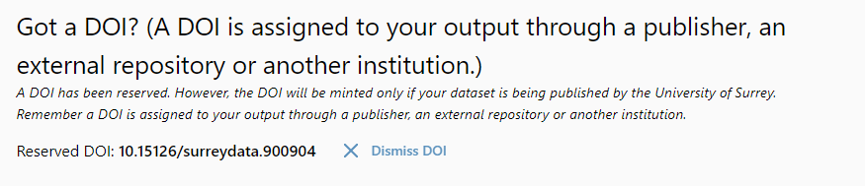

1. **“Date published”**
2. If you know when your data/code/model was published in an external repository, you can add it here.
3. If you are depositing the data/code/model today for the first time, you can add today’s date.
4. **“When was the data collected?”**
5. You can specify a date range for when your data/code/model was collected/measured/generated to be displayed in your record.
6. **“Language”**
7. You can indicate relevant language (e.g. English) for your data/code/model.
8. **“Add additional info, such as methods, coverage, etc.”**
9. You can add additional information to display on the data’s record in this section, including:
10. Geospatial Info
11. Methods
12. Coverage
13. Technical Info
14. If this information is captured in the “**description**” section or your README file, then you may want to skip this.

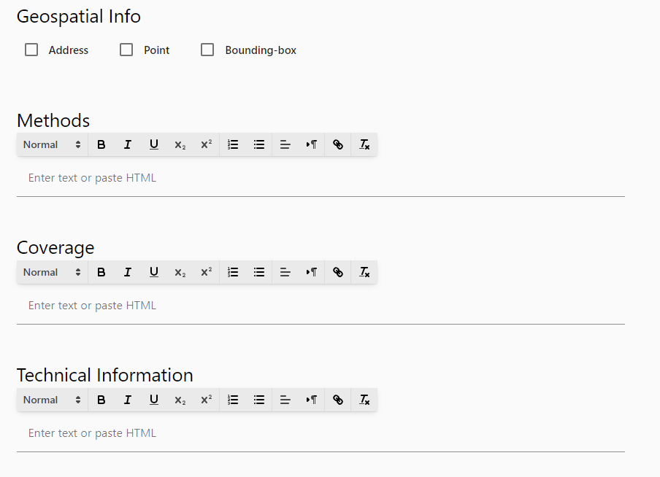

1. Click the RELATIONS Tab along the topto proceed to the next step.

Relations and review

1. **“Related grants”**
2. Start typing a grant name or ID number to see suggestions.

1. If you don’t see your grant, then click “**Add a new grant**” to add it.
2. Skip this if there is no grant associated with the data.

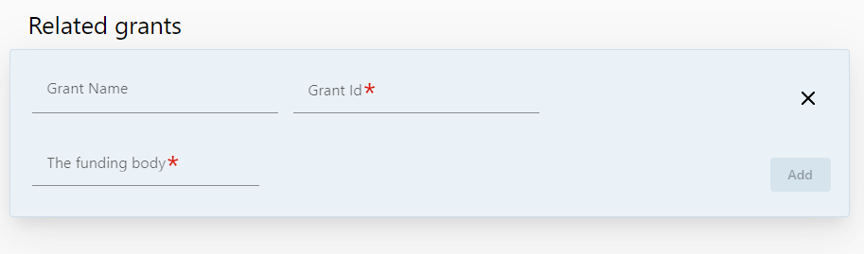

1. Click “**REVIEW**” in top right to go to final step. Here you will see a summary of the information you’ve provided.
2. **“Terms and Conditions”**
3. After you read the terms and conditions of publication, you must agree to them by *ticking the box*.
4. “**Add message to admin for this asset**”

If your data/model/code is related to another output e.g. a journal paper/report, please add the full reference here so we can include it in the Relationships Field.

1. **“Add copyright information”**
2. Used for journal articles so please Ignore.

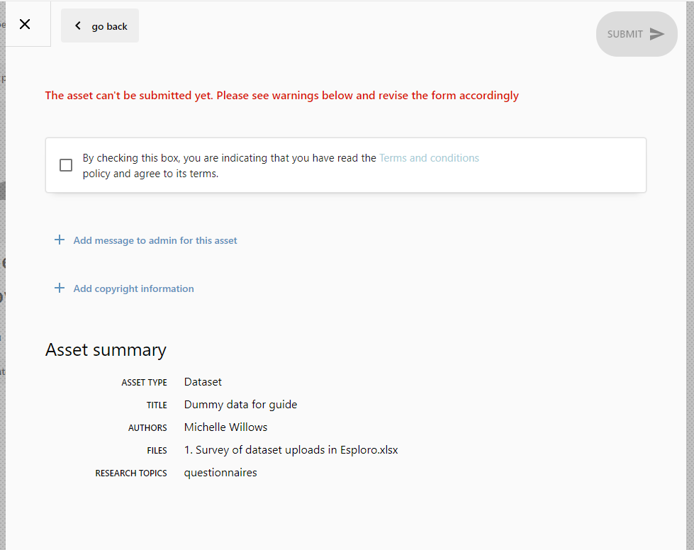 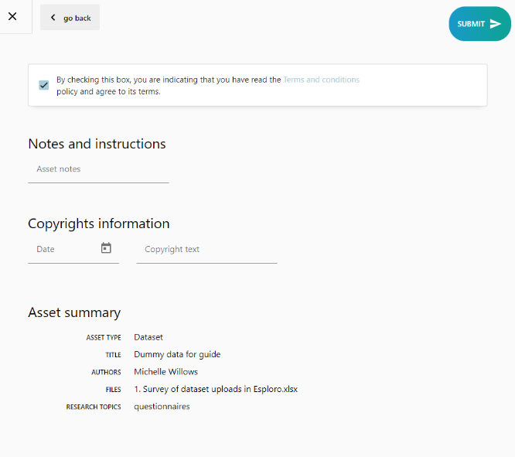

Submission, approval, and publication

1. Ready to submit your record? Just click on “**SUBMIT**” in top right.
2. A member of the Open Research team will review the record submission before its publication in our repository.
3. If there is an issue with your record submission or *any missing information*, we will let you know and return the metadata asset record to your workspace.
4. If approved, we will let you know the asset record has been published.
5. Once the data has been published, the *DOI will go live*, and your metadata asset record will be findable.
6. *Once the record has been “Approved”, you will no longer be able to edit the information contained therein*, apart from being able to upload additional files (e.g. final file version). So, if you wish any changes to be made, please contact us and we can make any updates on your behalf.
7. Only the metadata asset record will be made Open Access by default, such that any restrictions that you have placed on individual uploaded files and/or on links to externally stored files will be retained. This allows contextual details of your data/code/model to be found but the actual files/links **cannot** be accessed if marked as restricted/closed/embargoed.

If you have any questions, please contact [openresearch@surrey.ac.uk](mailto:openresearch@surrey.ac.uk).

**NOTE:** Unless explicitly stated in a collaborative contract where Intellectual Property Right (IPR) or data responsibility is retained by another institution, **all research data MUST be registered with the University by creating a metadata record in the University’s repository**, even if the data is hosted elsewhere (e.g., in a third-party repository), refer to: [research-data-management-procedure.pdf](https://www.surrey.ac.uk/sites/default/files/2025-03/research-data-management-procedure.pdf).