Is there a mid-career crisis? An investigation of the relationship between age and job satisfaction across occupations based on four large UK datasets
Ying Zhou, Min Zou, Mark Williams

This study provides robust empirical evidence to resolve a longstanding debate in the job satisfaction literature. Previous research has produced a wide range of findings on the relationship between age and job satisfaction. While few studies suggest that job satisfaction declines with age, there is considerable controversy over whether the positive relationship follows a linear or non-linear pattern. In other words, is there evidence of a mid-career crisis?
This study examines this relationship in depth by analysing four nationally representative datasets in the UK, which include both cross-sectional and longitudinal data from over 100,000 workers from all industries, occupations and geographical areas. The analysis revealed a U-shaped relationship between age and job satisfaction among workers in highly skilled occupations.
Job satisfaction starts high among young managers and professionals, gradually declines over time, and reaches its lowest point in midlife. The estimated ages at which workers reach this nadir vary across datasets. In the UK Skills and Employment Surveys (SES) and the Workplace Employee Relations Surveys (WERS), managerial and professional workers reported the lowest job satisfaction in their early 40s, whereas in the British Household Panel Survey (BHPS) and the UK Household Longitudinal Survey (UKHLS), the nadir occurs between the late 40s and mid-50s. These variations may reflect differences in sample composition or statistical methods (particularly whether fixed individual characteristics are controlled for). Despite differences in the timing of the midlife low, all datasets provide clear evidence of a U-shaped trajectory in job satisfaction for highly skilled workers across the career span. In contrast, workers in intermediate and lower occupational classes do not display the same U-shaped trajectory. This challenges the widespread belief that a mid-career crisis is a universal phenomenon.
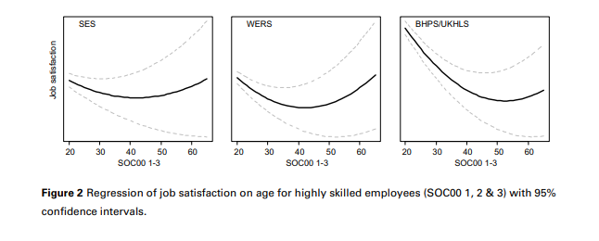
The fact that only managerial and professional workers experience a mid-career crisis suggests this phenomenon is not solely driven by biological changes, such as menopause, or life-cycle factors, such as increased family responsibilities (e.g. caregiving for both children and elderly relatives), since these factors are not unique to highly skilled workers. Instead, our evidence underscores the significance of the employment context, which shapes individuals’ expectations and experiences at work.
Understanding the relationship between age and job satisfaction can help individuals anticipate future challenges. For middle-aged workers, recognizing that a decline in job satisfaction during their 40s and 50s is relatively common can offer reassurance. This study suggests that such a dip is a normal part of the work-life cycle, particularly in managerial and professional occupations. Rather than expecting midlife to be a period of calm between the turbulence of adolescence and the challenges of old age, it should be viewed as a tricky period of transition marked by feelings of frustration and despondency. However, it is encouraging to note that this phase is typically temporary, and there is light at the end of the tunnel.
These findings also have broader implications for the economy and society. In the UK, around 2.9 million people aged between 50 and the State Pension Age are currently out of work (Government Office for Science, 2016). The large number of early withdrawals from the labour market may be partly accountable by declining well-being in midlife. Early transitions into economic inactivity present significant challenges for the UK economy, especially in the context of a rapidly ageing population, as the ‘brain drain’ of skilled and experienced middle-aged workers exacerbates workforce shortages. Insights into the patterns of well-being development across the lifespan, particularly the fact that it typically improves after midlife, can help both individuals and organizations make better-informed decisions about retirement timing.

References
Zhou Y, Zou M, Williams MT (2024). Is There a Mid-Career Crisis? An Investigation of the Relationship Between Age and Job Satisfaction Across Occupations Based on Four Large UK Datasets. Socio-Economic Review (featured in The Times, Science Daily, Personnel Today, HR Review, Yahoo News, The Marker, MSN, Phys.org, Workplace Journal, HR Now, Customer Experience Magazine, RTBF Actus, Le Point, L'Independant, La Depeche, Academia Médica, and Free Malaysia Today).

