Retention of hospital nurses and doctors: why it matters and how to achieve it

By: Giuseppe Moscelli, Professor in Economics, University of Surrey; correspondence email: g.moscelli@surrey.ac.uk

Health care is a labour-intensive sector that, over the last two decades, has been experiencing substantial problems in the recruitment, training and retention of healthcare professionals across many countries around the world. In wealthier, developed countries, ‒ such as the U.S., the U.K., Italy, Germany, Spain and the Netherlands ‒ the retention and job satisfaction of healthcare workers are nowadays felt as the most pressing issues, whereas the insufficient training and hiring of new healthcare workers have surfaced only in the last decade. The COVID-19 pandemic has only exacerbated a global healthcare workers’ crisis that has been ongoing long before the pandemic onset.

As a part of a broader research agenda, I lead a team of researchers that investigates the factors driving the retention of nurses and doctors employed by English NHS hospitals. Employee retention is generally defined as a continuous employment spell of the worker for the same organization, in our case a hospital, for a sustained period of time. The time component is critical, as is the component that distinguishes the idea of ‘employee retention’ from the concept of ‘employee turnover’: employee turnover can be defined at any time horizon, whereas employee retention is inherently related to the idea of continuity of employee services, or continuity of patient care in the case of hospital nurses and doctors. The English NHS represents an ideal institutional setting to studies these problems, for at least three reasons: the existence of high-quality administrative payroll data for NHS hospitals employee; the fact that the basic pay for its hospital nurse and physician workforce is fixed and set at national level, and so not subject to individual bargaining; and that the year-on-year retention of hospital workers, which in the English NHS is called ‘stability rate’, has been long monitored as a key policy variable.

Our main objective is broadening the understanding about which factors and interventions can improve nurse and doctor retention within their employer organization and within the public healthcare sector, and whether greater retention of these workers can improve patient health outcomes.
In an article recently published in the British Medical Journal we show a strong and stable association between the mortality risk of patients admitted to English NHS hospitals and the monthly turnover of hospital nurses and doctors leaving their hospital organization in the month prior to patient admission, in the years 2010-2019. The quitting of 20 nurses is associated with the increase in all-cause mortality risk by 35 deaths for every 100 000 hospital admissions in a given month, whereas the quitting of 7 senior doctors is associated with the increase in all-cause mortality risk by 14 deaths for every 100 000 hospital admissions in a given month. As shown in Figure 1, for nurses this association persists also with respect to the average turnover in the previous six and nine months, whereas for doctors the association persists also with respect to the average turnover in the previous six months. This relationship between clinical hospital staff and increased mortality risk is driven by emergency patients, as these are the patients whose risk of dying is greater if high hospital staff turnover compromises the continuity and quality of care, as many clinicians and health economists advocate.

Figure 1. Association of hospital staff turnover rates with hospital mortality, at different time lags (as reported in the BMJ article)
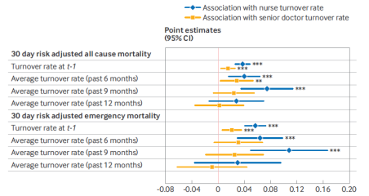

Notes. Hospital quality outcome is 30-day risk-adjusted mortality risk. The first and fifth values report the baseline estimates of the association of interest. The second to fourth and sixth to eighth values report the estimates of interest using the hospital mortality risk smoothed between t-1 and t+1 (according to a moving average of order 3) as hospital quality outcome, and the lagged hospital staff turnover rates and levels, respectively, smoothed over 6, 9, and 12 months as variable of interest. Vertical bars are 95% CIs based on heteroskedasticity and autocorrelation consistent robust standard errors, clustered at NHS hospital trust level. Significance level: **P<0.05; ***P<0.01. Sample size was 13,040 (monthly NHS hospital trust observations from April 2010 to March 2019 included). CI=confidence interval

These associational findings reported in the BMJ paper explain the importance to understand the factors determining the retention of hospital care workers. My co-authors and I have investigated these factors in another peer-reviewed article, recently published in Economica, finding that nurse retention is strongly associated with their engagement at work, while senior hospital doctors’ retention is strongly associated with nurse retention within the same NHS hospital organization. In particular: a 10% increase in nurse engagement is associated with a 1% increase in their stability rate and to a -8.5% decrease in nurse NHS hospital sector attrition rate; a 10% increase in nurse stability rate is associated with a 1.57% increase in senior doctor stability rate; and a 10% increase in nurse NHS leaving rate is associated with a 2.02% increase in senior doctor NHS leaving rate.

These results are explained by the fact that nurses have a lower occupational rank in hospital than doctors, although the nursing staff represents the largest share of the clinical workforce in NHS hospitals, with six nurses for every senior doctor. Nurses’ work is paramount not only for patients, but also for senior doctors, as they might be required to perform part of the nurses’ tasks, if too many nurses quit the hospital organization.

According to our Economica study, the quality of managerial inputs also matters to keep nurse engagement with their job high. In particular, as shown in Figure 2, nurse engagement is positively associated with line managers who are helpful with difficult tasks, who care for nurse wellbeing, communicate effectively, involve nursing staff in operational decisions and are reactive to nursing staff feedback.

[more on next page]

Figure 2. Managerial factors associate with hospital nurse and doctor engagement at work.

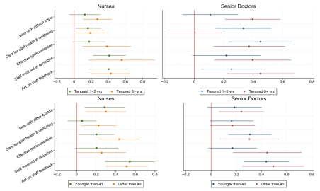

Given the strong associational relationship between nurse retention and their work engagement, the results on the managerial determinants of nurse engagement in Figure 2 pave the way for targeted policy actions that strengthen such engagement as well as other nursing job amenities. In another unpublished discussion paper, my co-authors and I evaluate exactly an intervention of this kind. The main goal of this Programme, which was rolled out at national level across all English NHS hospitals between July 2017 and March 2020, was to improve the retention of the hospital nursing staff by enhancing non-monetary aspects of their jobs, such as improved flexibility in shift work, recognition of good work, and training and career advancement opportunities. We can evaluate the causal effect of this policy, because a substantial number of hospitals was not ‘treated’ until the end of September 2019, allowing them to be considered as a valid control group. Figure 3 below summarises the main finding of our study: despite the lack of direct increases in pay, the Programme was effective in increasing the retention of nurses, both at hospital level and within the English NHS public hospital sector.

Figure 3. Effects of the 2017-2020 Retention Programme on the retention of English NHS hospital nurses.

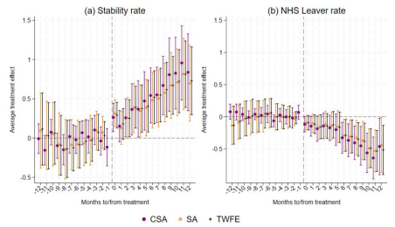Notes. Event study estimates of the 2017-2020 Retention Programme causal effect. SA= estimates using the Sun and Abraham (2021) method; CSA = estimates using the Callaway and Sant’Anna (2021) method; TWFE = estimates using the classic Two-Way Fixed Effect specification.
Additionally, we find that the Programme has generated larger retention effects in hospital organizations with better line managers, and also in hospital organizations characterized by fewer hospital sites. The last result is explained by the fact that organizational complexity may play a big role in the way that a workforce Retention Programme is actioned, and that more compact hospital organizations are probably characterized also by a nurse workforce more homogenous in terms of needs and work culture. Furthermore, our evaluation suggests that the Programme might have also decreased patient mortality risk in the ‘treated’ hospitals, in part due to the increase in nurse retention.
In summary, our research not only emphasizes the relevance of the retention of the nurse and physician hospital workforce, but it also highlights how such retention can be achieved by hospital managers and policy-managers. While the advancements in AI and automation may represent an epochal change for many industries in the near future, there is fair ground to believe that these technologies could be revolutionary to a lesser extent in a sector like health care, where such innovations are expected to complement human labour and augment its productivity, rather than completely replace it. In such context, the value of current and future research to understand how to improve the working conditions and the related retention of healthcare workers cannot be overstated, as these workers will likely remain key for the critical delivery of patient care and public health.

References

Giuseppe Moscelli, Marco Mello, Melisa Sayli, Adrian Boyle (2024). Hospital nurse and doctor turnover and patient outcomes: a retrospective longitudinal study on English NHS acute hospitals. In: The BMJ, British Medical Association BMJ Publishing Group

Giuseppe Moscelli, Melisa Sayli, Marco Mello, Alberto Vesperoni (2024). Staff engagement, coworkers' complementarity and employee retention: Evidence from English NHS hospitals, In: Economica, Wiley

Giuseppe Moscelli, Melisa Sayli, Jo Blanden, Marco Mello, Henrique Castro-Pires, Chris Bojke (2023). Non-monetary Interventions, Workforce Retention and Hospital Quality: Evidence from the English NHS. IZA Discussion Paper No. 16379

